Official Publication of ALOA—An International Association of Security

roressio

Jew!

**ING**

a

PLUS!

fireg Perry found a Screw Loose

How to Take Rction Rgainst Phony Locksmiths,

**\*\*#****«******«^£-^** 3-DIGIT 303 BRECKH. CAMPCML PO BOX 47070 ATLANTA GA 30362-0070

11 illilli.mll.il 11 mill II Mill ml ml II ml mill Ml

nd More!

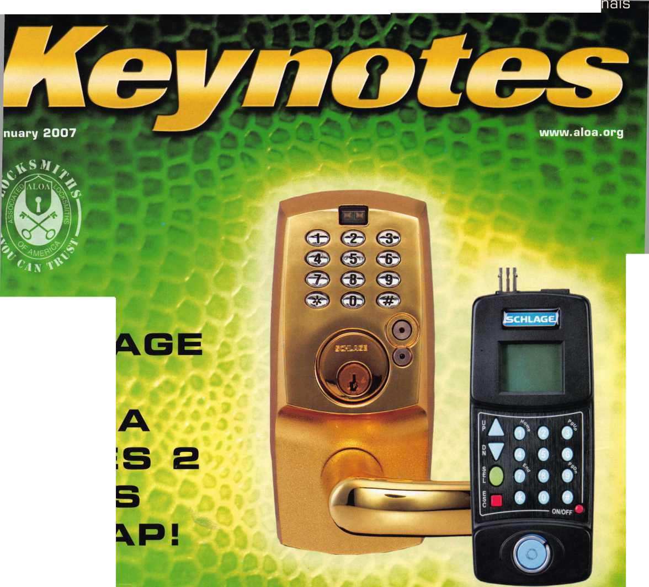

**OUR STAND**

**WE RE IN BUSINESS TO HELP YOU**

**REDUCE DOWNTIME**

**Commercial vehicle insurance designed to help you get back on the road.**

When your vehicle is out of business, so are commercial vehicle insurance as well as other you. That's why Ajllstate provides fast and fair insurance products designed to help keep your

claim service. Yoijr local Allstate agent offers business in the race. Are you in Good Hands®?

**1-888-322-3078**

**CALL NOW TO SPEAK TO AN ALLSTATE AGENT NEAR YOU.**

**Subject to availability and qualifications. Allstate Insurance Company and Allstate Indemnity Company, Northbrook, IL. Allstate County Mutual Insurance Company, Irving, TX. Allstate New Jersey Insurance Company, Bridgewater, NJ. The Cupped Hands" logo is a registered service mark and “Our Stand" is a service mark of Allstate Insurance Company. NASCAR* is a registered trademark of the National Association for Stock Car Auto Racing, Inc. © 2007 Allstate Insurance Company,iNorthbrook, IL.**

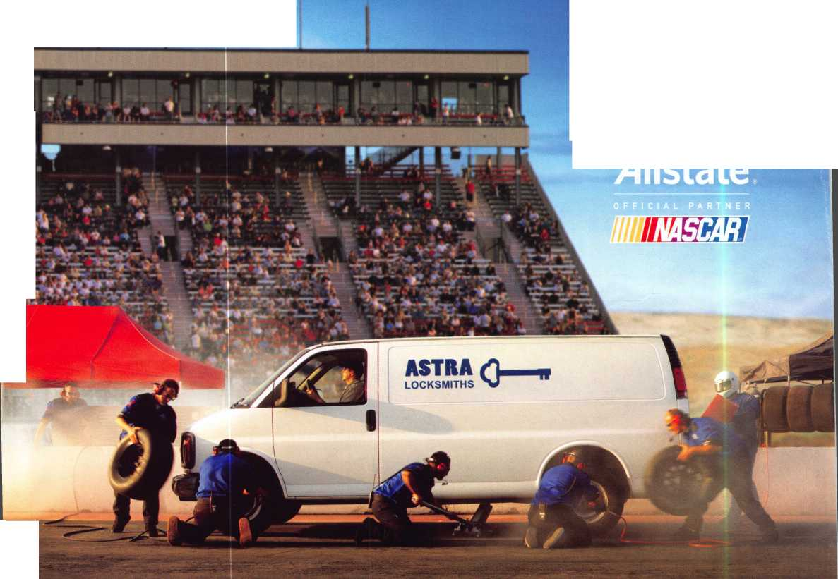

A Name You Know

As a business owner, you know the importance of a  
good name. Your name is your reputation. Your name  
stands for all that you offer in products and services.  
It’s a symbol of who you are. So, we thought you  
might like to know that Allstate, the name you know  
for insuring your personal vehicle and your home,  
also offers a business auto policy to help protect vehi-  
cles used in your locksmith business.

The following are coverages typically included in  
our business auto policy that might be important to  
you as a business owner:



Get What's  
Coming To You

Business Auto Liability coverage

* Higher limits up to $2,000,000 per occur-  
  rence.
* Protects you if you are legally responsible  
  for injuries and damages arising out of  
  the ownership, maintenance, or use of  
  business vehicles.
* Cost is based on several factors, includ-  
  ing garage location, type and use of vehi-  
  cle, and the violation and accident activi-  
  ty of your drivers.
* Additional Insured coverage may be  
  required when you contract with govern-  
  mental agencies or bid on local  
  commercial jobs.
* Generally not available on a personal  
  auto policy.
* Usually is no charge to add an insured to  
  a Commercial Auto policy.

Hired Auto coverage

* Provides liability coverage for those  
  vehicles you rent, hire or borrow for  
  business use.
* The premium for hired auto liability  
  coverage is based on the estimated  
  annual rental cost.
* Tools and Special Equipment
* Provides protection to permanently  
  attached equipment on your vehicle.
* You will need to let your agent know the  
  value of the equipment to include in the  
  cost of the vehicle.

You’re good at your business. Your insurance com-  
pany should be the same way.

Contact an Allstate agent to discuss your business  
auto insurance needs. To be referred to an agent,  
please call 800.859.0247 or email  
[abisO@allstate.com](mailto:abisO@allstate.com).

Subject to availability and qualifications. Insurance coverage is  
subject to policy terms.

Allstate Insurance Company

Allstate Indemnity Company  
Northbrook, IL

Allstate County Mutual Insurance Company  
Irving, TX

Allstate New Jersey Insurance Company  
Bridgewater, NJ

allstate.com

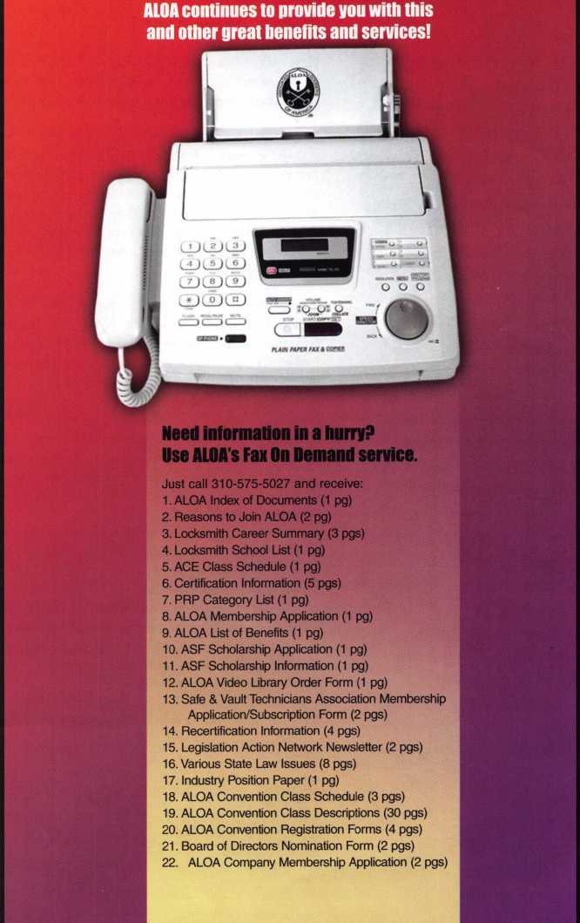

310**-**575-5027



© 2005 Allstate Insurance Company, Northbrook, IL

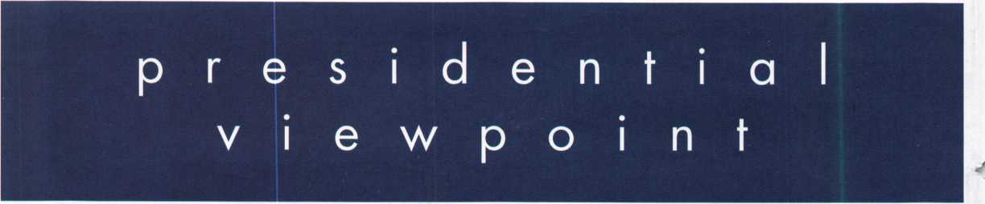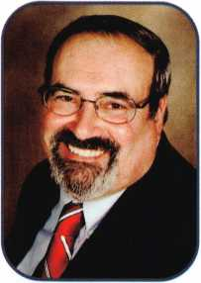

Dear Members,

Happy New Year !

How many of us have wished that we had a fresh start, a do-over? Yet, in a manner of speaking, every New Year gives  
us the perfect opportunity to do just that. We make resolutions in the hope of improving our lives and, if we seriously

pursue those promises to ourselves, our situations do improve.

I have resolved, for many years now, that communication in our indus-  
try must improve. I have reiterated through my presidential messages  
and addresses to many associations and chapters, the significance  
of our communications. It is the key to our success as local associa-  
tions, chapters and ALOA. Communication is the thread that runs  
through and binds our professional lives and our industry. To that end,

I am suggesting a New Year's resolution that you may want to make  
your own.

It only takes one person to start the process. Is your local, state, or  
regional association an affiliate of ALOA? The Affiliate Program is  
a "sharing communication program" to allow ALOA to help keep all  
locksmiths apprised of every local, state, national and international  
event. It is information that you and all of your professional peers  
need to have. So, if your other associations are not members of the  
program, why not inquire about becoming an Affiliate and get the  
necessary information? If you have questions, contact your regional  
director. It only takes your resolve to bring a world of information to  
your doorstep. There is strength in numbers. If we all work togeth-  
er, we can create a more secure locksmithing future for tomorrow  
through communication.

Speaking of communication, my trip to Seoul, Korea to visit with our  
chapter there, was a great success. Thanks to Mr. Shin and the very

active membership, they had a great banquet, along with several meetings and educational events. During the gener-  
al membership meeting, I addressed the chapter and answered questions from the members. This was made possible  
because I was accompanied by Joe Lee, a former ALOA International Director. He not only helped me with translat-  
ing, but on the proper protocol both at meetings and social events. I am hoping to write a more detailed article for  
Keynotes about the chapter and locksmithing in the Far East this year. Thank you, Mr. Shin and all the chapter mem-  
bers for a wonderful experience!

May the New Year bring all our members much health, wealth and happiness.

Take 'er easy!

Sincerely,

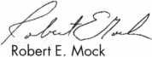

dr a a sssi

Associated Locksmiths

of

AMERICA INC.

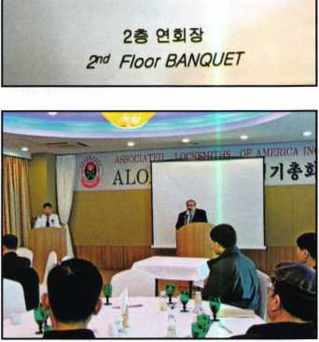

1

Keynotes • January 2007

**RING of a KING**

|  |  |  |  |
| --- | --- | --- | --- |
| Member Name Sponsorships | | William J. McElheney CML | ....18 |
|  |  | James E. Fowler Sr, CML | ....18 |
| Kwok-kei Leung | .222 |  |  |
| Toshihiro Asa no | .123 | Ronald E. Heidzig | ...18 |
| Henry W. Raymond | .92 | Joe J. Lee CRL | ...18 |
| Yuriko Yanai | .82 | Peter R. Hall | ...17 |
| Mary S. Ohmit CPL | ...66 | Eugene R. Altobella Jr | ...17 |
| William Lee CRL | 66 | Kenneth E. Kim CRL, CPS | ...16 |
| Charles C. Robertson CML | .65 | Joseph W. Whitaker CPL | ...16 |
| Clifford D. Lipscomb CML, CPS | .62 | John A. Ilk CRL, CPS | ....16 |
| David M. Troiano | 61 | Evelyn V. Wersonick CML, CPS .... | .15 |
| Michael B. Groves | 55 | Joseph P. Ferrero CML | ...15 |
| Jack Hobin CPL | .51 | John W. Soderland CML, CMST .. | ...15 |
| William B. Neff CML CPP PSP | .48 | Michael E. Jordan Jr, CML | ...15 |
| Ken Dale | 44 | John J. Greenan CML, CPS | ....15 |
| Jim Williams CRL | .43 | Brian J. Reetz | ....15 |
| C Allan Halverson | .40 | Steve L. Cothron | ...15 |
| Myeong-Rae Cho | 38 | Leonard J. Passarello CPL | .14 |
| David M. Lowell CML, CMST | .37 | Gary F. Teams CPL | 14 |
| Salvatore J. Dulcamaro CML | ..36 | John D. Cannon CML | 14 |
| Dana L. Barnum CML | .35 | Timothy J. Moore CRL | 14 |
| Barry K. Leas CRL | .35 | Gregory L. Perry CML, CPS | .14 |
| Hans Mejlshede CML | .34 | Paul M. Souber | 14 |
| Peter Sarailian CRL | .33 | James T. Brickler CML | ...14 |
| Scott L. Henke CPL, CPS | .33 | John F. Engel CRL | ...14 |
| William L. Young CML, CPS | .33 | Richard C. Sievers | .14 |
| Danny W. Rudd CPL | .32 | Robert C. Rodocker CPL | ...13 |
| Robert D. DeWeese CML | .32 | Calvin G. Harris CML | .13 |
| William T. Beranek | .32 | Robert E. Mock | ...13 |
| James L. Hancock CPL | .32 | Barry L. McMenimon CPL | ...13 |
| Larry A. Warnick CML | .31 | Basil W. Shannon CPL | 12 |
| Robert W. Duman Sr, CML | .31 | William J. Wickward CML | ...12 |
| Eugene R. Altobella Sr | .31 | Bruce J. Tarbet CML, CPS | .12 |
| John C. Elliott Jr, CML, CPS | .30 | Robert M. Massard CRL,AHC | ...12 |
| Dallas C. Brooks | .28 | Charles E. Batcke CRL, CPS | ...12 |
| Breck H. Camp CML | .27 | Thomas Demont CML, AHC | 11 |
| Lawrence F. Smith Jr, CML | .27 | J Casey Camper CML, CPS | .11 |
| Marian M. Swann CRL | .27 | Gordon R. Racine CML | 11 |
| James M. Watt CML, CPS | .27 | Bruce P. Eagan CML | ...11 |
| Jeffrey S. Nunberg CML, CMST | .26 | Todd K. Ladwig CML, CPS | .11 |
| Philip A. Rovenolt CPL | .26 | Kevin R. Wilson CML, CPS | ...11 |
| J Thomas Hood CML | .26 | Carroll T. Mann | .11 |
| John L. Shandy CML | .25 | Andrew A. Edmunds CML, CPS | ...11 |
| Elvis D. Hammerschmidt CPL | .25 | Maurice R. Horne CML | ...11 |
| Anthony J. Ramunno CML, CPS | .24 | Daniel S. Enriquez CRL | ...11 |
| Man-Soo Seo RL | .23 | Charles E. Haas CML | ...10 |
| Jerome L. Cohen CML | .22 | Ralph O. Warren CML | .10 |
| Peter K. Gauthier CPL, CPS | .22 | Thomas R. Smith CPL | .10 |
| Michael C. Olson CRL | .21 | Timothy K. Chow | 10 |
| Takashi Kuwana CRL | 21 | Richard T. Johnson CPL | 10 |
| John S. Dorsey CML, CPS | .20 | Raymond C. Lusk CML | ...10 |
| James J. Cawby CML, CPS | .20 | Dana L. Lee CML | ...10 |
| William P. Grant CRL | .20 | Vincent L. Formon CML, CPS | .10 |
| Walter W. Lascar Sr., RL | .19 | Carroll T. Croson Jr | .10 |
| Thomas G. Vandersteen CML, CPS | .19 | David M. Howdle | ...10 |
| Ernest W. Wright | .18 | Kenny R. Carroll | 10 |
| James E. Gruber CPL | .18 |  |  |

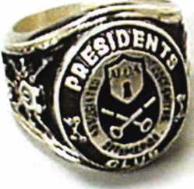

How can I join the President's Club?

You can earn a membership in this prestigious club by recruiting  
just 10 new members for ALOA.

*Any ALOA member may participate.

What do I get?

When you recruit 10 members, you receive a  
handsome blue blazer with a President's Club crest.  
For each additional five members you recruit, you  
receive a lapel pin with gold-filled numbers, indicating,  
your recruiting successes.

You also get the satisifaction of knowing that you are  
helping your association, helping your industry grow,  
and you are helping fellow locksmiths achieve success.

How do I get started?

Mail the form below to the ALOA office for a supply of  
applications (800) 532-ALOA or FAX (214) 819-9736.  
One President's Club credit is awarded for each new  
applicant. Credit is awarded only after the membership  
application is pproved. However, the credit will apply  
for the period in which the application is received.  
Failure to identify yourself as the sponsor on the applica-  
tion form at the time it is submitted to ALOA for process-  
ing will forfeit any credit.

Yes! I want to join the ALOA President's Club.

Please rush me applications so I can start earning credit toward membership in the club!

Name

Company

Address

City State Zip

Mail this form to ALOA • 3500 Easy St. • Dallas, Texas 75247-6416

feat

KING COBRA 2007

10

New Schlage King Cobra

New locks, new programmer and new PC applica­tion create simple, more durable solution for smaller businesses & facility access control management.

**14**

Member Spotlight: Joe Brown

Find out more about Joe and his Gulf Shores, Alabama lockshop, Aarons Lock Service.



Locksmith Ledger Editorial

Read on to find out what one of the major areas of discussion in the locksmith community has been during the last ten years.

by Gale Johnson - (reprinted with permission of Locksmith Ledger)

22

The Postman Just Might Have A Screw Loose

Greg Perry tells you why taking extra parts and being prepared is always wise.

by Greg Perry, CML, CPS

**28**

How to Take Action Against "Phony Locksmiths"

Tim McMullen exposes how many consumers have been over-sold, under serviced, or just plain lied to by those posing as professional locksmiths. Read on to see how you can take action against them!

**30**

The 7 Elements of Executive Presence

Learn how you can develop your "WOW" Factor.

Departments

u

r

e

s

**42**

Dorma & OSU's Massive Athletics Complex Project

Find out what happened when OSU facility managers set out to build a new state-of-the-art Recreation and Physical Activity Center (RPAC), one of the largest, most complex college facility projects in the country.

|  |  |  |
| --- | --- | --- |
| r |  |  |
| AD INDEX | |  |
| Allstate | ..Inside Front Cover |  |
| Fax on Demand | 1 |  |
| ALOA President's Club | 3 |  |
| ALOA 2007 | 7 |  |
| Letro Truck | 13 |  |
| PBP | 17 |  |
| Safetech 2007 | 19 |  |
| Clearstar | 21 |  |
| Turn 10 | 23 |  |
| Cal-Royal | 25 |  |
| Jet Hardware | 27 |  |
| ALOA Member Recruitment. | 31 |  |
| Ultralift | 33 |  |
| A&B | 40 |  |
| Locksmithing UNL | 40 |  |
| Coast Safe & Lock | 40 |  |
| HL Flake | 41 |  |
| Ben Jim | 43 |  |
| Door Jam Armor | Inside Back Cover |  |
| CCL | Back Cover |  |
| L. |  |  |

|  |  |  |  |  |  |  |  |  |
| --- | --- | --- | --- | --- | --- | --- | --- | --- |
| Presidential |  | Executive | 5 | Calendar | 8 | Classified | 34 | Legislative 38 |
| Viewpoint | 2 | Applicants .... | 6 | Core | 9 | Associate Members | 36 |
|  |

Visit our NEW website at [www.aloa.org](http://www.aloa.org)

executive

Volume 53, Issue 1

Additional contact information for the ALOA Board is available on the ALOA website— [www.aloa.org](http://www.aloa.org) or by contacting the ALOA office at 3500 Easy Street; Dallas, TX 75247; (800)532-2562; FAX (214)819-9736; e-mail [aloa@aloa.org](mailto:aloa@aloa.org).

Editor & Director of Creative Services

Betty Southerland [betty@aloa.org](mailto:betty@aloa.org)

Advertising Sales

Kim Hammond voice: 817-645-6778

Fax: 817-645-7599 e-mail: [adsales@aloa.org](mailto:adsales@aloa.org)

Executive Director

Charles W. Gibson, Jr., CAE [charlie@aloa.org](mailto:charlie@aloa.org)

Associate Executive Director

David Lowell, CML, CMST [david@aloa.org](mailto:david@aloa.org)

Convention & Meetings Manager

Jo Anne Mims [joanne@aloa.org](mailto:joanne@aloa.org)

Operations/Membership Manager

Mary May [mary@aloa.org](mailto:mary@aloa.org)

Director of IT Operations

Greg K. Jackson [greg@aloa.org](mailto:greg@aloa.org)

Comptroller

Kathy Romo [kathy@aloa.org](mailto:kathy@aloa.org)

Membership Development Manager

Ellen R. McEwen [ellen@aloa.org](mailto:ellen@aloa.org)

Membership Coordinator Shelly Jett

Convention & Meetings Assistant Karen Lyons PRP/Education Coordinator Shelley Melton

Mail Room Coordinator Kevin Wesley

Graphic Designer Margarita Garza

Accounting Coordinator Joyce Nixon

Executive Assistant Sue Langford

Assistant Education Manager Bob Stafford, CML Legislation Manager Tim McMullen

Contributors

Jerome Andrews, CML Paul Chandler, CRL Claire Cohen, CML Brian Costley, CML, CMST Eric Costley, CRL

Ray D'Adamo, CML Billy Edwards, CML Dan Graffeo, CRL,CMST Jim Hancock, CPL Jeff Nunberg, CML, CMST

Randy Simpson, CML, CPP Robert Stafford, CML Dave Thielen, CML Greg Perry, CML,CPS

Tom Seroogy

Charles Stephenson, CPS

Dennis Watanabe, CML, CMST

Mission Statement: The Associated Locksmiths of America, Inc. is dedicated to enhancing the professionalism, education and ethics among locksmiths and those in related sectors of the physical security industry. With approximately 10,000 members in the United States, Canada and the freeworld, ALOA is poised to help members obtain the knowledge, the strength, and the confidence to perform their role in the physical security field with pride and dignity. But it is only through active involvement and participation that ALOA can fully achieve its potential—and can help members to achieve theirs.

Policies: **Keynotes**® is the official publication of the Associated Locksmiths of America, Inc. (ALOA). **Keynotes**® acts as a moderator without approving, disapproving, or guaranteeing the validity or accuracy of any data, claim, or opinion appearing under a byline or obtained or quoted from an acknowl­edged source. The opinions expressed by the authors do not necessarily reflect the official views of ALOA. Also, appearance of advertisements and new products or service information does not constitute an endorsement of products or services featured by the Association. The Association does not accept responsibility for the inaccuracy of any data, claim, or opinion appearing in this publication, due to typographical errors on the part of the authors, Association staff or its agents.

Editor's Note: This publication is designed to provide accurate and authoritative information in regard to the subject matter covered. It is provided and disseminated with the understanding that the publisher is not engaged in rendering legal or other professional services. If legal advice and other expert assistance is required, the services of a competent professional should be sought.

Authors7 Payment: Payment for eligible submissions to Keynotes will be based on the following criteria: topic, time spent and past contributions. Authors who regularly submit to **Keynotes**® are generally paid a higher rate. The latter is especially true of authors who write to fit specific editorial needs and submit said copy by **Keynotes**® deadlines. As a general guideline: Average payment for a 750 word, business or light' technical article would be $200. Payment for a 1500 word article involving significantly higher time and research efforts would be $400.

Payment will not be offered for articles submitted by ALOA employees or members of the ALOA Board of Directors (unless material is of a technical nature), nor for articles submitted by a company that promote that company's products or services. ALOA reserves the right not to pay for articles sub­mitted by an individual(s) that promote a particular company's products or services.

Disclaimer: The Associated Locksmiths of America, Inc., (ALOA), reserves the right to refuse any article for any reason. Additionally, ALOA reserves the right to edit, amend or modify any article submitted for publication in order to preserve technical accuracy, clarity, fairness or grammatical correct­ness. ALOA will make the best efforts to notify the author of any changes. The extent of ALOA's liability for any article or information contained there­in will be a notice of correction or retraction in the next possible issue.

**Keynotes**® (ISSN 0277 0792) is published monthly except for the combined June/July issue by The Associated Locksmiths of America, Inc., 3500 Easy St., Dallas, TX 75247-6416. Telephone: (214) 819-9733; FAX (214) 819-9736; e-mail [aloa@aloa.org](mailto:aloa@aloa.org). Subscription rates for members—$15.00 per year. Periodical class postage paid at Dallas, Texas. POSTMASTER: Send address changes to: Keynotes, 3500 Easy St., Dallas, TX 75247-6416. © Copyright 2003, All rights reserved. No part of the contents may be reproduced or reprinted in any form without prior written permission of the publisher.

President

Robert Mock

(856) 863-0710 [president@aloa.org](mailto:president@aloa.org)

Secretary

John Soderland, CML, CMST  
(414) 327-5625

[secretary@aloa.org](mailto:secretary@aloa.org)

Directors, Northeast

Tom Foxwell  
(410) 206-5772  
[nedirector@aloa.org](mailto:nedirector@aloa.org)

Robert D. DeWeese, CML, CPS  
(410) 285-0101  
ned i rector@a loa. org

Directors, Southeast

Tom Gillingham, Jr., CML, CPS

(615) 264-0747  
[sedirector@aloa.org](mailto:sedirector@aloa.org)

Ken Kupferman, CML, CPS

(813) 232-7600  
[sedirector@aloa.org](mailto:sedirector@aloa.org)

Director, North Central

William Smith, RL  
(920) 893-5282

Guy Spinello, RL  
(815) 394-1000

[ncdirector@aloa.org](mailto:ncdirector@aloa.org)

Director, South Central

CD Lipscomb, CML, CPS  
(903) 874-3522  
[scdirector@aloci.org](mailto:scdirector@aloci.org)

Directors, Southwest

Greg Parks, CRL  
(858) 271-1155  
[swdirector@aloa.org](mailto:swdirector@aloa.org)

Julie McCluney, CRL

(714) 636-5652  
swd i rector@aloa. org

Director, Northwest

Keith E. Whiting, CML, CFL  
(360) 601-5656  
[nwdirecto@aloa.org](mailto:nwdirecto@aloa.org)

Director, European

Hans Mejlshede, CML  
(453) 539-3939  
[eurdirector@aloa.org](mailto:eurdirector@aloa.org)

Director, Associate

Dan Floeck  
(800) 231-4105

asdirector@aloa .org

Trustees

[trustees@aloa.org](mailto:trustees@aloa.org)

Randy Simpson, CML, CPP  
(281) 240-5959

John J. Greenan, CML, CPS  
(773) 486.2030

William Young, CML, CPS  
(610) 647-5042

Past Presidents

2003-2005 William Young, CML, CPS  
2001 -2003 Randy Simpson, CML  
1999-2001 John Greenan, CML, CPS  
1997-1999 Dallas C. Brooks  
1995-1997 David Lowell, CML, CMST  
1993-1995 BreckCamp, CML  
1991-1993 Henry Printz, CML  
1989-1991 Evelyn Wersonick, CML, CPS  
1987-1989 Leonard Passarello, CPL  
1985-1987 Joe Jackman, CML  
1983-1985 Stanley Haney, CPL  
1981-1983 Louis LaGreco, CPL  
1979-1981 John Kerr, RL  
1977-1979 Clifford Cox, CML  
1974-1977 Charles Hetherington  
1972-1974 Gene Laughridge  
1970-1972 William Dutcher, RL  
1968-1970 Constant Maffey, RL  
1966-1968 Harold Edelstein, RL  
1964-1966 William Meacham  
1962-1964 Robert Rackliffe, CPL  
1960-1962 Edwin Toepfer, RL  
1956-1960 Ernest Johannesen



Keynotes • January 2007



**AZ**



applicants

for membership

Chino Valley

Michael A. Pruett

Sponsor: William Lee CRL

***CA***

Temecula

Thomas G. Seroogy II

**CO**

Thornton

Javon L. Smith

**FL**

Fort Lauderdale

John C. Blinn

Sponsor: David E. Welter

CRL

James N. Brandt

Sponsor: David E. Welter CRL

Matthew S. Irving

**IL**

Chicago

Yehuda Barhany

Sponsor: William T. Beranek

Wheaton

Gordon T. Sheehan

Sponsor: William T. Beranek

**Ml**

Belleville

Ronald Schroeck

Sponsor: Robert C. Noble CML

**MN**

Saint Paul

Brian Kjellberg

Sponsor: Dana L. Lee CML **Willmar**

Randy L. Dickerson

Sponsor: Gary W. Pearson

**NE**

North Platte

Corban Heinis

Sponsor: John Somers

***IN***

Thompsons Station

Gregory Miller

**TX**

Dallas

Michael S. Rodriquez

Sponsor: Clifford D. Lip­scomb CML**, CPS**

Plano

Janies M. Cersosimo Jr.

Sponsor: Robert H. Stafford CML

**VA**

Arlington

John F. Roche

Sponsor: Michael B. Groves

**WA**

Eastsound

Anthony Maiuro

Sponsor: John **C.** Conant **Spokane**

Rodney Fuller

Sponsor: Kevin Morrisey

Wl

**Madison**

Kevin M. Ralph

**Great Britain**

Aldershot Hampshire

Peter Williams

London

Yahya Abuomar

Sponsor: Ken Dale



Shenzhen City, Guang

Wen Hua Mai

Sponsor: Kwok-kei Leung

Chang Hong Wong

Sponsor: Kwok-kei Leung



Nittedal

Vidar Myhre

Sponsor: Bruce Burby

These applicants are scheduled for clearance as members of ALOA. Tbe names are published for member review and comment within 30 days of this Keynotes issue date, respectively, to ensure  
applicants meet standards of ALOA's Code of Ethics. Protests, if any, should be addressed to the Membership Department and must be signed. Active Membership applicants (a) have worked in  
the industry two or more years. Allied Membership (AL) applicants are not locksmiths, but work in a security-related field. Apprentice Membership (AP) applicants have worked in the industry less than two years.



Keynotes • January 2007



Start Your Engines!

This year, with a great location and a schedule chock-full of exciting classes and events, we are pulling out all the stops to celebrate the ALOA Convention and Security Expo in Charlotte, North Carolina.

Having built an international reputation among locksmiths as a powerful resource to explore industry innovation and form industry alliances, ALOA 2007 is the ideal place to learn, network or to showcase your security-related business on the show floor.

This year weve thought of everything from an exciting location to a comfort­able hotel and a convention center that is equipped to handle your every need. The exhibit hall promises to be overflowing with the latest technology and new mer­chandise.

|  |  |
| --- | --- |
| july 22-29, 2.007 charlotte, north Carolina | |
| t-Lj/ |  |
| v 4 5  3 3  xlOOOr/rn»n | 6 % |
| ^2 | \ |
| A M | 71 „ | |
| ✓ q AUOA 2°° | 8* |

aloa convention and security expo

***51st ANNUAL***

**Dont miss out!**

800-532-2562

upcoming events

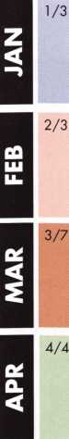

Hometown Buffet • Franklin, Ohio Ohio Valley Chapter Annual Meeting Contact: Chairman Terry McClain, CRL 513-464-8806

|  |  |  |  |  |  |
| --- | --- | --- | --- | --- | --- |
| Holiday Inn Select • Tulsa, Oklahoma  2007 Annual Distributor's Show, 9am-4pm Oklahoma Master Locksmith Association Contact: Harry Sher, CML  479-471-8890 • [hsher@starband.net](mailto:hsher@starband.net) | | 2/7  2/10 | TBA • Franklin, Ohio  Ohio Valley Chapter Meeting  Renaissance Charlotte Suites Hotel Charlotte, NC • NC Locksmith's Assc. Regional Trade Show • [www.ncla.us](http://www.ncla.us) | 2/14 | TLA Convention • Houston, Texas. [www.texaslocksmiths.org](http://www.texaslocksmiths.org) |
| TBA • Franklin, Ohio  Ohio Valley Chapter Meetin | g | 3/5-10 | Safetech 2007 • Lexington, KY  Safe & Vault Technicians Association [www.savta.org](http://www.savta.org) |  |  |

Hometown Buffet • Franklin, Ohio Ohio Valley Chapter Meeting Contact: Chairman Terry McClain, CRL 513-464-8806

z

o

o

</>

ELF Convention 2007 • Riga, Latvia European Locksmith Federation Exhibition - Social events -Education [www.elf2007.com](http://www.elf2007.com) • [ruta.reinika@prplus.lv](mailto:ruta.reinika@prplus.lv)

**UPCOMING ACE CLASSES**

January 13, 2007

January 13, 2007 February 9-10, 2007 February 10, 2007 March 8-9, 2007

March 15-16, 2007 March 28 - 30, 2007

April 14-15, 2007 April 21, 2007 April 26 - 28, 2007

May 7- 12, 2007

Detroit, Ml • Locksmiths Security Association Robert C. Noble, CML • Intrchgble. Core Fundamentals <http://home.earthlink.net/~lockwriter/idl> .html 810-385-9329 • [noblelock25@sbcglobal.net](mailto:noblelock25@sbcglobal.net) Casper, WY • Wyoming Locksmiths Association Automotive Update with Transponders Contact: Gene Ficek, CPL • 605-642-4542 Welch, MN • Minnesota Chapter of ALOA For specific course schedule please contact:

Dana Lee, CML • 612-722-9181

Detroit, Ml • Locksmiths Security Association

Life Safety Codes w/L-07 PRP

Contact: Robert C. Noble, CML • 810-385-9329

Lexington, KY • SAFETECH 2007

For specific course schedule please contact:

ALOA Education • [education@aloa.org](mailto:education@aloa.org)

800-532-2562x104

Northbrook, IL • Clark Security Products

For specific course schedule please contact:

Joan Emrick • 858-974-6737

Vancouver, British Columbia • British Columbia

Association of Security Professionals

Bill Beazley • 14 ALOA Certified Classes

[lockpicker@helmz.com](mailto:lockpicker@helmz.com) • 604-291-0444

Kansas City, MO • Missouri-Kansas Locksmith Assc.

For specific course schedule please contact:

Bob Turner • 816-525-5522

Kearney, NE • Nebraska Chapter of ALOA

Push Button Mechanical Lock Manipulation

Elmer Howard • [safeman@cox.net](mailto:safeman@cox.net) • 402-676-8973

Denver, Colorado • Central & Southern Colorado

Locksmths Association • 9 ALOA Certified Classes

Contact: Barry Meyers, CPL • 303-688-1404

Dallas, Texas • ALOA Training Center

Six-Day Basic Locksmithing Course

ALOA Education • [education@aloa.org](mailto:education@aloa.org)

800-532-2562x104

May 17-19, 2007 Dallas, Texas • ALOA Training Center 3-Day Automotive Locksmith Course ALOA Education • [education@aloa.org](mailto:education@aloa.org) 800-532-2562x104

**UPCOMING PRP Sittings**

1/21/2007

1/21/2007

2/11/07

2/17/07

3/10/07

3/18/07

3/25/07

Sunday 9:00 am • Hebron, KY • Terry McClain, CRL Ohio Valley Chapter of ALOA • 513-464-8806 Sunday 1:00pm • Muskego, Wl • [prolock@aol.com](mailto:prolock@aol.com) John Soderland, CML, CMST • 414-327-5625 Sunday 8:00am • Welch, MN • Dana Lee, CML Minnesota Chapter of ALOA • 952-887-1199 Saturday 8:00am • Houston, TX • ALOA Certification Texas Locksmiths Association • 800-532-2562x104 Saturday 8:00am • Lexington, KY • ALOA Certification SAFETECH2007 • [education@aloa.org](mailto:education@aloa.org) • 800-532-2562x104 Sunday 8:00am • Northbrook, IL • Joan Emrick Clark Security Products • 858-974-6737 Sunday 8:00am • Novi, Ml • Bonnie Weston IDN Hardware Sales* 313-591-1150

3/31/07

4/28/07

4/28/07

5/12/07

Saturday 8:00am • Vancouver, BC • ALOA Certification British Columbia Association of Security Professionals [education@aloa.org](mailto:education@aloa.org) • 800-532-2562x104 Saturday 8:00am • Roseville, Ml • Robert C. Noble, CML Locksmith Security Association • 810-385-9329 Saturday 6:00pm • Denver, CO • Barry Meyer, CPL Central & Southern Colorado Locksmiths Association 303-688-4104 • [acomal@gwest.net](mailto:acomal@gwest.net) Saturday 1:00pm • Dallas, TX • ALOA Certification ALOA Training Center • [education@aloa.org](mailto:education@aloa.org) • 800-532-2562x104

**Contact the ALOA Education Department for a list  
of classes and training offered in-house.**

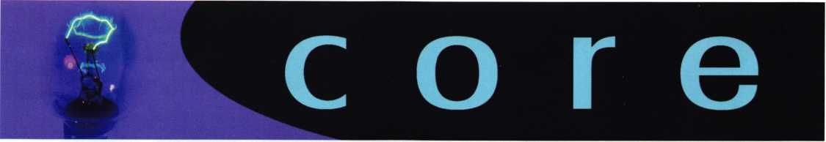

Bump Key Video & Phony Locksmiths Getting Major Press

Geraldo At Large recently ran a story about a Bump Key How-To-Video posted on YouTube. You can view the seg­ment on [www.geraldoatlarge.com](http://www.geraldoatlarge.com). (Go to the bottom right- hand corner listed under "Knowledge is Power") The actual Bump Key video can be found at: <http://youtube.com/watch?v=ya9CsMioPxA>

The Ft.Worth Star Telegram also ran an article about phony locksmiths called **Unlicensed Locksmiths Can Open**

**Door to Woe** with direct quotes from ALOA's very own Executive Director, Charles W. Gibson, Jr. You can find the article on the Ft. Worth Star Telegram's website, [www.star-telegram.com](http://www.star-telegram.com). Just do a search in archives for the article title mentioned above.

DeWALT BREAKS INTO NEW MARKET, LAUNCHES PAVEMENT BREAKER

WITH HIGH-LEVEL OF DURABILITY, PERFORMANCE AND LOW VIBRATION

**-** New Breaker is First in Class to Offer Two Years of Free Service -

December 2006 - DeWALT®, a leading manufacturer of industrial power tools, today announced the launch of its first heavy-duty pavement breaker (D25980K). This new breaker is designed with innovative features and patented technology to provide end users with increased durability, performance, and low vibration. It is also the first breaker in its class to include a two-year free service warranty. Available in early 2007, the D25980K is ideal for plumbers, waterproofers, demolition crews, and public utili­ties workers to break up concrete and asphalt on the job- site.

For a visual demonstration of the breaker's performance, please visit:

<http://www.dewalt.com/us/products/tool_detail.asp?produ> ctlD= 15695 and click on the virtual product tour button.



KABA* UNIVERSITY

COLLEGE OF ACCESS CONTROL

FOR IMMEDIATE RELEASE Kaba University is Bringing the Classes to You!

Winston-Salem, NC (Dec. 15, 2006)

Kaba Access Control is pleased to announce that Kaba University is now available for regional convention and local seminars. Kaba University will bring classes to you!

Each class offered by Kaba U. provides attendees with com­plete hands-on training and an in-depth understanding of the products - complete with product tips and shortcuts to assist in everyday lock servicing. After successful comple­tion, attendees will receive a Certificate of Product Training and will be promoted on the Kaba website as a Factory Trained Dealer - promoting you as a retail provider for spe­cific products.

All classes have been approved by ALOA, as well as several states, to provide points towards ALOA PRP re-certification.

For more information or to set up a training class, please email to [KabaU@kaa.kaba.com](mailto:KabaU@kaa.kaba.com) or call 1-336-725-1331.

In Memory of..

* John L. Hughes - member since 1976
* Kenneth W. Cord **-** member since 2004
* ALOA member Madeline Shandy passed away December **6,** 2006. She had been a member of ALOA since 1976. She lived in Boulder**,** Colorado. Her husband John Shandy served on the ALOA Board for more than

20 years.



COBRA

New Schlage King Cobra Series 2 Locks and SNAP Programmer Fill Important Voidstems

Keynotes • January 2007

**New Locks, New Programmer and New PC Application Create Simple, More Durable Solution for Smaller Businesses & Facility Access Control Management**

FORESTVILLE, CONN. - December 14, 2006 - Ingersoll Rand Security Technologies has filled an important void between mechanical keys and electronic locking sys­tems with its new, improved Schlage King Cobra Series 2 Locks, SNAP™ programmer and SNAP! PC. Created for small to medi­um sized business and facility managers, this next generation in the Schlage King Cobra lock family, the King Cobra Series 2 locks are smarter, more durable and very afford­able, providing an easy to manage and intu­itive offline lock solution. An upgrade

from mechanical keys, King Cobra Series 2 and SNAP! let end users secure doors, man­age lists of authorized users and access an audit trail from the lock to see who went where and when. The SNAP! programmer is USB compatible and the SNAP! PC applica­tion is very simple to use. The new King Cobra 2 and SNAP! will also help lock­smiths and security dealers create new and recurring revenue streams to grow their business. By upgrading their customers to

electronic access control and, then, manag­ing those openings for the customer, rev­enues will grow. "Most access control

solutions are designed either for the most basic user, where all programming is done at the keypad, or for high security applica­tions, where complex software, training and experience are key," explains Chris Nieshalla, marketing manager with Schlage electronic security. "The King Cobra Series 2 (KC2) lock and SNAP! programmer cre­ate a nexus between the simplicity of a USB Thumb Drive and access control lock management. The system is specifically designed for the end user with multiple locks and employees, who finds it impracti­cal to program each lock manually through the keypad, yet does not require the fully featured functions of higher price lock and software solutions. Examples include retail operations, small to medium sized business­es, property management firms, commercial office buildings, schools and many larger institutional facilities." Several improve­

ments and features have been developed for this series of KC locks. New features include the ability to be programmed using the SNAP programmer and a new lock memory capable of storing up to 1000 individual users and 1000 audit trail events. Other fea­tures include a keypad and an iButton cre­dential reader, providing increased security over mechanical locks. The KC2 may also be used with more fully featured software programs, such as Schlage Security Management System Express, offering the ability to program time zones. It is a lock that can grow with a customer's needs. Weather-resistance has been improved on

Keynotes • January 2007

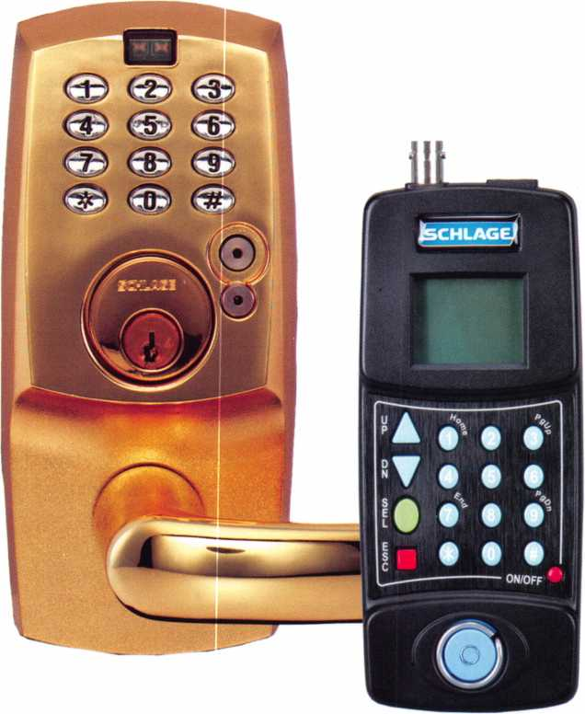

**“The new King Cobra  
2 locks and SNAP!  
do not require  
certification or  
special training.  
More importantly,  
the customer will  
not forget how they  
work, even when  
there are weeks  
between uploading  
or downloading."**

the KC2 locks by providing an elevated level of water­proofing on key electronic parts. Several models are

available. The KC5000 Series 2 is designed for cylindrical and mortise door preps. The KC2 Office Function lock provides a convenient lock/unlock button on the inside of the door, making it quick and easy to allow credential-free passage during the day and credential-only access at night. The narrow stile KC9000 Series 2 locks are designed for use with aluminum doors that rely on various latches and exit devices to secure the opening. The KCR 2 retrofit model supplies easy upgrading from a mechanical pushbut­

ton lock by matching the existing door prep and covering

the lock footprint for a clean finish. "The SNAP

Programmer and SNAP PC Application takes off-line access control management to a whole new level, a much simpler one," emphasizes Nieshalla. "Our customers have asked us to make software that manages people and doors and the handheld programmer that delivers data to the lock more intuitive. The new King Cobra 2 locks and SNAP! do not require certification or special training. More importantly, the customer will not forget how they work, even when there are weeks between uploading or

fi

**2**

Keynotes • January 2007

downloading." With the King Cobra 2, programming ports allow the locks to be managed using the SNAP!™ handheld programmer, a unique, USB-based device that moves information from the computer to the lock. Partnered with the new, complimentary SNAP! PC appli­cation, which is available for download on the Schlage website, it is a valuable tool that is used to add and delete

users, as well as download audit trails from the lock. The

SNAP! PC application is used to create a list of users and door names, which are then merged together, determining who can go where and when and is extremely simple to use. The intuitive layout, drag and drop control and func­tional design let administrators manage a database of users, PIN codes, iButton credentials and audit trails effortlessly. Files can be shared, emailed or transferred between PCs.

When finished working in the application, the SNAP! programmer is connected to the USB port on the PC. An "export" button is used to send all relevant information to the programmer. Once locks are installed, the SNAP! pro­

grammer is then taken to the lock and plugged in to down­load its instructions to the lock. At the same time, an audit

trail can be retrieved. "As needs grow and change for a

facility, this new King Cobra Series 2 provides a pathway," adds Nieshalla. "For the end-user just getting into electron­ics as a means of key control, programming the lock using the keypad may be all that is needed. When the number of doors and employees increase, the user can begin using the SNAP! programmer, which makes programming locks easi­er and provides an audit trail of who went where and when. Later, the user may want the locks to automatically lock and re-lock at certain times of the day. Without buy­ing new locks, the user can simply invest in the Schlage Security Management System Express software to increase

their functionality." For more information, interested

dealers and integrators should contact their local Ingersoll Rand Security Technologies Consultant office or whole­saler. They can also visit [www.schlage.com](http://www.schlage.com). ■

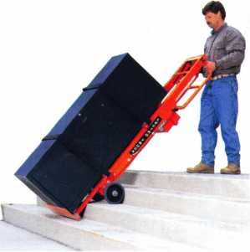

V

*Lectro Truck*

**| STAIR CLIMBING? SYSTEM**

Visit us online at:

[www.lectrotruck.com](http://www.lectrotruck.com)

...or call us today at:

800-619-0625

The Lectro-Truck will make it easier for you to break back a load, climb and descend steps, and even load onto your truck or trailer!

Save on damage costs.

Save on injury costs.

Save on labor costs.

The bottom line: You save money!!

The Lectro-Truck makes this all possible - all while having a 1500 # capacity!! Call us today to find out what you have been missing.

Keynotes • January 2007



**MEM**

potlignt

Welcome to our new monthly feature! Each month we will highlight a current ALOA mem­ber & their lockshop with a short bio and in-depth questions. To be considered or to recom­mend a fellow ALOA member please read the information provided at the end of this article.

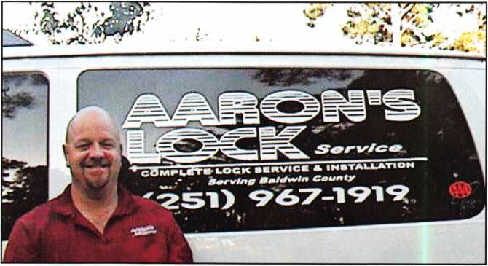

oe Brown, owner of Aarons Lock Service, provides complete lock service to the Alabama Gulf Coast. They provide mobile locksmithing services, safe work, and are the AAA provider for the County.

**1545 Gulf Shores Pkwy #203 Gulf Shores, AL 36542 [www.aaronslockservice.com](http://www.aaronslockservice.com)**

1. Tell us about your background in security and your experience in locksmithing.

Joe: I started my own shop 25 years ago in St. Louis, Missouri. I went out on my own after spending some time working with established locksmiths and studying professional literature and practicing on my own. This gave me “hands-on” experience from the very start. I have always been mechanically inclined and my interest in locksmithing and security grew until I branched into security systems for autos, homes and businesses.

During my early years, I served as a reserve police offi­cer in the City of St. Louis which gave me a unique insight into the need for good security.

1. How long have you had your lock shop open?

Joe: I have been in the locksmithing business for 25 years. This is Aaron’s Lock Service’s 10th year serving the Gulf Coast.

1. How many employees do you have?

Joe: Aaron’s Lock Service currently employs 11.

1. Name one thing in your lockshop that says the most about you.

Joe: Our goal of doing the best job possible every time. I’m a perfectionist, which can drive some people crazy. However, my employees know that our businesses’ suc­cess stands or falls on that pursuit of perfection, so we will continue down this path.

1. How did you get involved in the business? i.e. starting point?

Joe: After trying a number of different jobs after high school, I found myself interested in locksmithing first as a hobby, then I realized I could do it professionally. Once I learned how much I enjoyed the work, I was able to start my own business in St. Louis. Although I lacked experience, I discovered that if I treated my cus­tomers fairly and courteously, and didn’t leave until the job was done right, they were willing to endure my rookie errors.

1. What are the changes that youVe noticed in the security technology recently?

Joe: The increased use of transponders for vehicles. The manufacturers have made it more difficult for lock­smiths to work on automobiles, as it becoming a very specialized segment.

1. What do you see as the future of security? Where are we headed in today’s age of technology?

Joe: I see the increasing use of electronics. Like most technology items, as electronic locks become main­stream, prices will drop. Once electronic locks surpass mechanical locks, the need for combination changes and key makes will be reduced. Those services will be replaced by the servicing of these new electronic locks.

1. How do you stay informed about new products and security techniques? i.e. magazines, conventions, classes, etc.

Joe: I read the ALOA magazine monthly and attend classes and seminars throughout the year. As our indus­try continues to evolve, we as professionals must stay current.

1. How has having a website contributed to your lock shop business? Would you recommend it?

Joe: We recently have added our website and believe it will offer another avenue for our customers to commu­nicate with us and find information about our company and the services we provide. I recommend setting up a website, as in business this is becoming standard, like fax machines were several years ago.

1. Do you find that other locksmiths in the Gulf Shores area work together on referrals and work- flow?

Joe: Yes, we do work well together. I would like to per­sonally thank Don Epp, Jim Lockey, Roy Weeks, and Cliff Dukes. I would not be where I am today without their referrals early on while staring my business.

Keynotes • January 2007

1. What advice can you give to an aspiring  
   security professional?

Jo e: With dedication to the customer and providing  
professional service, locksmithing can be a great and  
rewarding career choice. Providing professional service  
to customers requires treating them fairly, ethically and  
honestly. Becoming a true professional requires the  
proper training and licensing, meeting all the necessary  
requirements and the need to continue learning  
throughout their career in order to stay current with  
the industry. Becoming a member of ALOA helps you

to stay informed, and network  
with other professionals at  
seminars and classes.

1. Can you remember your  
   first big security job? What  
   can you tell us about it?

Joe: Actually, I remember  
best the first job I did when I  
started out as a locksmith. It  
was for Kurtis Schmidt at  
Sureway Carpet Cleaning. It  
was a combination change on  
some Kwikset 880 s, and it  
took all afternoon. Not only  
did I serve a customer that  
day, but I made a friendship  
that still remains today.

1. How has life changed

for you as a locksmith in the past few years?

Joe: In many ways it has remained the same, but as  
electronics have entered into the industry, it has  
become more complicated. For example, now that  
more automobile manufacturers are integrating  
transponders into their keys, you can no longer just  
make a key for any vehicle.

1. Give us your biggest locksmithing horror story,  
   toughest job, or the job that taught you the  
   biggest lesson.

Joe: When I had been in the business for about four  
years, I accepted a large job from a major corporation  
that involved the installation of a great deal of new  
hardware and lots of master keying. I was really happy  
to get the contract and readily used my available cash  
and credit to do the job. After finishing the work and  
presenting the bill, I was complimented on the quali-  
ty of the job and told I would be paid at the next

billing cycle, which was at  
the end of the quarter -  
which had just started. So  
for almost 90 days, I was  
stretched to the max to keep  
things flowing. I was really,  
really happy when I got that  
big check, but the bigger  
thing I learned was to make  
sure I understood EVERY-  
THING about a contract  
before getting into one.

1. What do you like most  
   about your job?

Joe: Dealing with my cus-  
tomers. They are why I  
enjoy being a locksmith.

1. Do you feel that lock-

smiths have gotten a bad rap recently in the news?

Joe: Like almost any industry, there are a few busi­nesses which create a bad reputation for everyone.

It is important for all of us, with the leadership of ALOA, to educate the public. Whenever customers request service, they need to ensure the business they are dealing with has the proper licenses and insurance. Displaying your business as an ALOA member signi­fies your dedication to ALOA’s Code of Ethics.

*“Whenever customers  
request service*, *they need  
to ensure the business they  
are dealing with has the  
proper licenses and insur-  
ance. Displaying your  
business as an ALOA  
member signifies your  
dedication to ALOA’s  
Code of Ethics. ”*

**6**

Keynotes • January 2007

1. Name a few things that you think locksmith business owners should do to help their businesses prosper and grow.

Joe: Locksmiths like any other business these days must stay current with new technologies in order to compete, but they must not forget where they came from. Treat your customers right, and they will be loyal customers forever.

**\*You must be a current member of The Associated Locksmiths of America in order to be recommended for our Member Spotlight feature. If you would like to be recommended or would like to recommend some­one else please email our Keynotes Editor, Betty Southerland at [betty@aloa.org](mailto:betty@aloa.org)**

1. The business of locksmiths has been around for a very long time. How do you feel about being a part of that in todayfs technologically advanced world?

Joe: Locks have been used for thousands of years, basi­cally using mechanical technology. Now as technology evolves, we must evolve also, or otherwise we will be left behind. Also, the pace of business today, like most things has become faster. You no longer deal in days, but in hours and minutes now.

1. What is your favorite place in Gulf Shores?

Joe: Desoto’s Restaurant, run by my good friends Chris & Rosemary Steele. If any ALOA member ever visits Gulf Shores, stop by Desoto’s and enjoy some great seafood.

1. What do you think is the biggest obstacle facing security professionals, if any?

Joe: The toughest challenge is the increasing availabili­ty of information about security systems. Criminals access this information to devise ways of beating our best efforts. The industry will have to accelerate its research and development and marketing of new sys­tems in order to keep an edge on criminals.

. canaoMOin* oouaoaoouooo*

CLAIM CHECK

0004115

YOUR FIRM NAME HERE

123 Main Street

YOUR TOWN. STATE AND ZIP  
Phone 123-4567

N° 4321

**Professional Business Products**

Invoices Tags *Call for a free*

Checks Key Fobs *brochure and samples*

**Business Magnets 1-800-355-6322**

**Cards Labels [www.pbp2000.com](http://www.pbp2000.com)**

Keynotes • January 2007

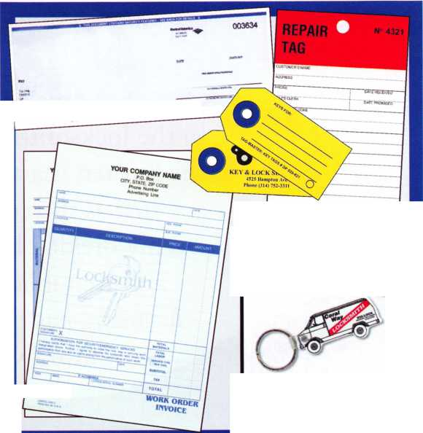

Locksmith Ledger Editorial |

By Gale Johnson, Editor-In-Chief (reprinted with permission of Locksmith Ledger)



One of the major areas of discussion  
in the locksmith community during  
the last ten years has been licensing.  
Just as the country is almost

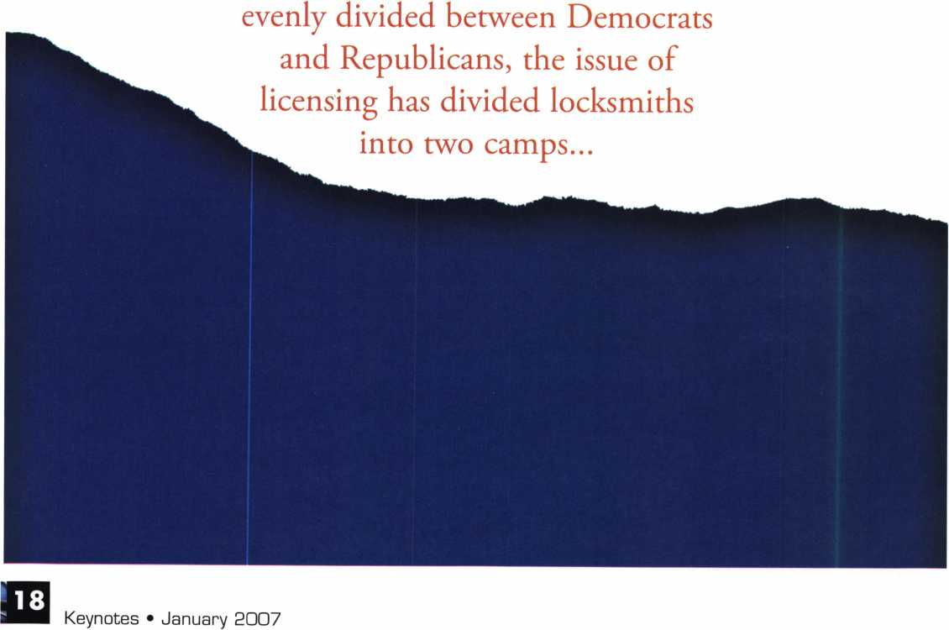

This year we’re back in LEXINGTON for the 150th Anniversary of Sargent & Greenleaf.

***THE RACE STARTS HERE***

**Keeping up with the  
latest the industry has  
to offer has never been  
this important - or this  
FUN! When it comes to  
learning about the latest  
in safes and vaults, time  
is of the essence.  
SAFETECH** 2007 **fea-  
tures an all-new menu of  
classes, covering every**



***OUR SAFETECH 2007 SPONSORS!!***

**SARGENTANDGREENLEAF**



**MARCH 5th thru MARCH 10th, 2007**

LEXINGTON

**KENTUCKY**

**214.819.9771**

**[www.savta.org](http://www.savta.org)**



Licensing has not been a rousing early success in the states  
where it has been adopted. California locksmiths had to  
learn some rules of carpentry. Texas locksmiths had severe  
restrictions on what electronic security they could install.  
Many locksmiths in Illinois thought that licensing was just  
another form of taxation without representation.

Any sweeping change such as licensing is never seen as  
necessary until there is a crisis. We now have a crisis in the  
locksmith industry and it is caused by the battery drill  
brigades. A few companies with centrally located phone  
banks are at the root of the problem. With hundreds of  
phone numbers in yellow pages across the country, these  
guys are sending people out on emergency lockouts,

Any sweeping change such as licensing  
is never seen as necessary until there is  
a crisis. We now have a crisis in the  
locksmith industry and it is caused by  
the battery drill brigades.

the Chicago area also have over 200 new suspected phone  
bank listings at last count.

Phone bank giants made a mistake in Chicago by listing  
phoney addresses to make it seem as though people were  
calling a local locksmith. Mike Bronzell is a Chicago area  
locksmith who got mad about that situation and single-  
handedly took action in several ways.

Mike first alerted locksmiths about the issue by giving  
talks at association meetings. The original idea was to hire  
a lawyer and take the matter to court. That proved costly  
and time-consuming. Mike next approached the Illinois  
Department of Professional Regulation. This agency is the  
watchdog for locksmith licensing, but is overworked and  
understaffed.

Finally Mike Bronzell took his case to the media. He kept  
calling TV stations until they staged several sting opera-  
tions which got coverage on TV and newspapers. Mike

reportedly drilling out cylin­ders, and charging much high­er than average pricing.

These phone bank giants have had success in some parts of the country. A former New York locksmith informed me recently that his business dis­appeared once his yellow pages were flooded by the phone bank crews. Yellow pages in

Keynotes • January 2007

found one job done by the phone bank locksmiths where an elderly man had been charged over $1,000 for a lockout. This case went to court and ultimate­ly caused the city and state governments to sit up and take notice. As a consequence, one locksmith phone bank has been suspended from doing busi­ness in Illinois. Another phone bank operation is under investigation at this time.

Mike Bronzell used the Illinois locksmith licensing law to prod the government into action. In this case licensing was a positive help.

One person can make a difference. Mike Bronzell proved that beyond any doubt. I

Editors Note:

Mike Bronzell is a member of ALOA. Working with the Legislative Department to combat this problem. (See adjoining article)

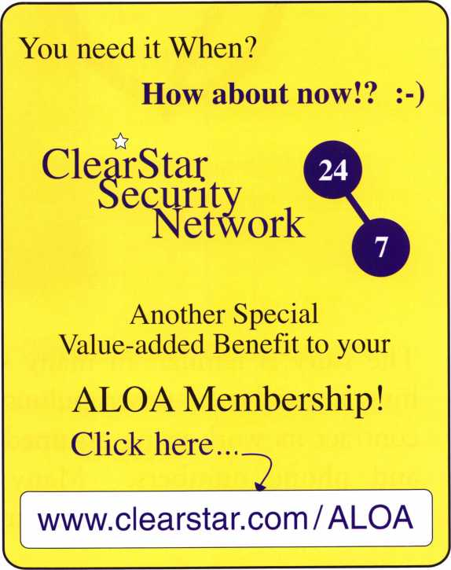

Keynotes • January 2007

How to Take Action Against “Phony Locksmiths”

By: Tim McMullen



The story is familiar in many states: an out-of-state company hires a number of unscrupulous individuals in the area to sub­contract its work using assumed business names, fake addresses and phone numbers. Many times consumers have been over-sold, under serviced, or just plain lied to!

**22**

Keynotes • January 2007

The Illinois Attorney General filed criminal charges against a New York locksmith operation for setting up phony storefronts with unlicensed individuals practic­ing locksmithing that lead consumers to believe they were dealing with local companies. The action was successful, and the company was ordered to pay thou­sands in restitution, to cease operations and to no longer do business in the state under a new name or any of the 25 different names the company had been using in local telephone directories!

ALOA encourages locksmiths who are facing this same situation to go to their state’s Attorney General who can take the appropriate legal action against these fraudulent companies. ALOA recently sent a letter to all Attorneys General urging them to pursue this mat­ter in their state. To contact your state’s Attorney General, go to [www.NAAG.org](http://www.NAAG.org).

ALOA is also empowering you to take immediate action when these fraudulent operations show up in your city. Go to [http://www.aloa.org/pressroom/con- sumerguide.html](http://www.aloa.org/pressroom/con-sumerguide.html) for a Press Release that you may send to your local print and broadcast news media outlets. Make sure you put in the date and the name of your city in the highlighted areas.

Finally, ALOA has enlisted the help of ALOA mem­ber Mike Bronzell (see accompanying article) to help identify these phony locksmith scams. Please send any website links to [legislative@aloa.org](mailto:legislative@aloa.org) or fax yellow page ads to 214-9736 and we will follow up.

For further assistance, contact ALOA Legislative Manager, Tim McMullen at 214-819-9733 x300 or [tim@aloa.org](mailto:tim@aloa.org) ■

IN-STOCK...MORE SAFES

***FREE Freight Program***

*(30 States)*

AMSEC FireKing **BaM** HAYMAN **M El LINK y/CTOK**

**TURPI tO**

**WHOLESALE SERVICE**

800-848-9790

Keynotes • January 2007



**st Might**

**HAVE A**



By: Greg Perry, CML, CPS

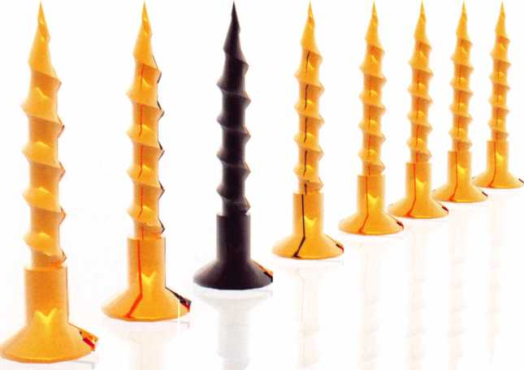

My friend Bob Haner called to see if I had any thoughts about a loose dial on a Post Office safe seen in photo 1 locked and photo 2 unlocked, the lock also did not always open the first time dialing the combination. Guessing it might be an S&G 8400 series Group 1 lock with an old style Centispline dial I asked if the dial had the turn knob in the center. After explaining a little bit about S&G Centispline dials he went to work but was stopped by a pin that didn’t move in the back of the door. Centispline dials have a potential problem and may fall off if not properly maintained. Bob’s a good lock­smith but doesn’t do much safe work so he referred the job to me. Doctors refer patients to specialists all the time. Locksmiths should do the same with safe work, or any job you don’t have either the knowledge or right inventory of parts to handle the job professionally.



Keynotes • January 2007

Sure enough look at the pin in photo 3 on the back of the door, the pin didn’t move up, down or sideways but it did turn with a pair of pliers. The pin turned out to be a bolt with a round head. I’m not sure if this is a factory item or if someone took the time and effort to make this round head bolt but why? I’ve asked a couple of other safe technicians who feel it’s probably factory but are also not sure. The chances are it’s a factory made pin. Once the bolt was removed we could now access the lock to service it and fix the loose dial. Removing the dial revealed a little surprise; the dial was not a Centispline. Instead it was a standard dial, just loose on the spindle.

Doctors refer patients to specialists all the time. Locksmiths should do the same.

The safe has a few unique features after the pin head bolt. The first thing you’ll find after removing the back panel is that the lock is still concealed from view. It’s covered by the bolt retraction bar or channel that runs top to bot­tom seen in photo 4. Removing this bar requires a few steps. First to the left of the bolt channel is a two pivot assembly that keeps the bolt bar from racking as it moves. Next there are eight large “C” clips seen in photos 5 and 6, one each side of the four bolts that attach the bolts to the bolt bar. Finally once the clips are removed the door locking bolts that go through holes in the bar can be removed. If you only want access to the lock you can remove the top six clips on the upper three bolts, leaving the lower bolt in place and using it as a pivot to drop the bolt bar as shown in photo 7. Once this is out of the way the six screws that hold the lock cover can be removed along with the

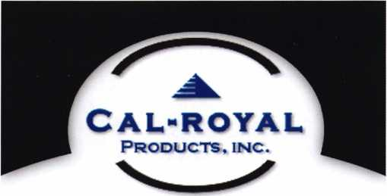

EXPLORER

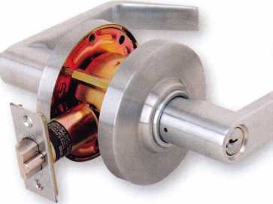

Non Clutch Mechanism, "XP" Series

Fits All Major Manufacturers Thru Bolt Locations

COMMANDER

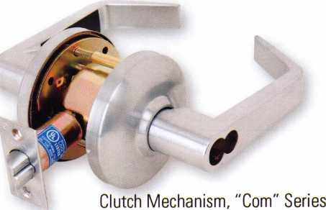

Large 1C Format

9800 EXIT DEVICES

1

Grade 1 Heavy Duty Exit Devices  
Available in all Architectural Finishes

**Cal-Royal Products. Inc.**

**6605 Flotilla Street. City of Commerce. CA 90040 U.S.A.**

**Tel: (323) 888-6601 • (818) 888-6601 • (800) 876-9258  
Fax: (323) 888-6699 • (818) 888-6699 • (800) 222-3316  
E-maiL [sales@cal-royal.com](mailto:sales@cal-royal.com) • Website: [www.cal-royal.com](http://www.cal-royal.com)**

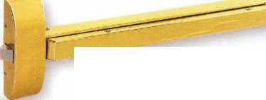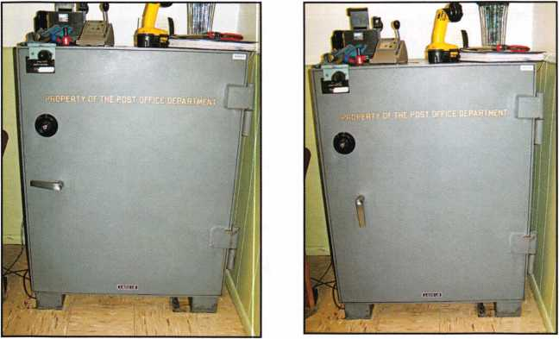

Photo 1 - Locked

Photo 2 - Unlocked

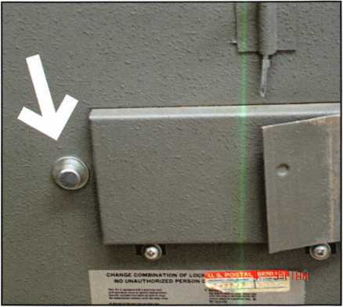

Photo 3

Photo 4

Photo 5

Photo 6

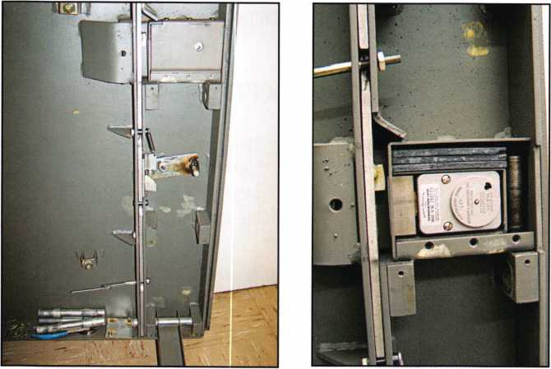

cover. Underneath this cover in photo 8 we see three hardplates stacked on top of the left hand mounted lock and a one- inch diameter rod to the right of the lock. Side or top drilling this safe is probably more difficult than front drilling.

Another thing to note is the bolt exten­sion block on the end of the lock bolt. If you should decide to replace the lock, either drill and tap the new bolt or reuse the existing lock bolt with the extension.

Photo 7

Photo 8

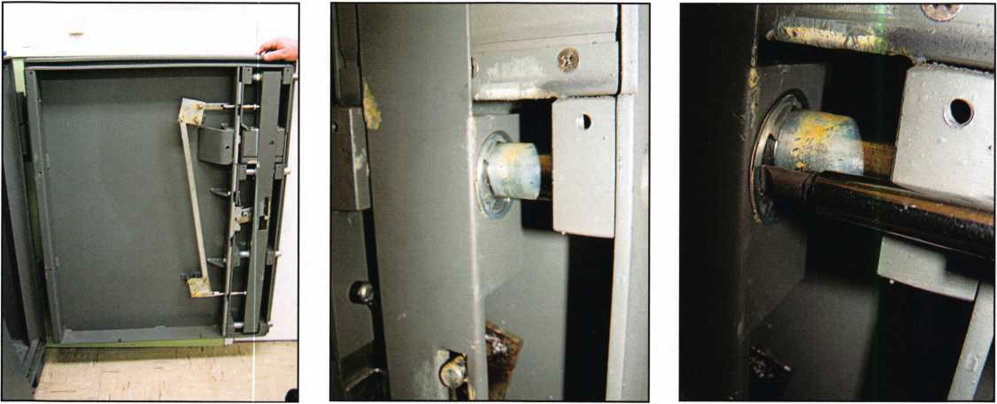

**Professional Products for Professional Locksmiths**

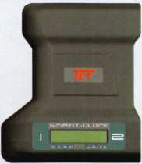

**Smart Clone**

**For AH Cloneable  
Keys... Including  
Ford, Infiniti &  
Toyota**

**Smart Clone  
Key Blanks**

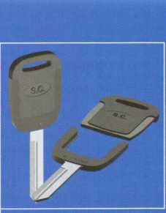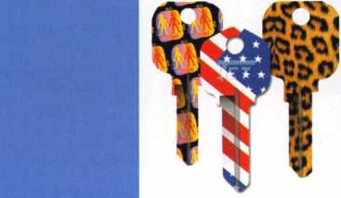

**Largest Selection of Groovy Keys... Anywhere**

**Automotive**

**Transponder**

**Keys**

**USDVA V ILLINOIS**

DUPLICATION

PROHIBITED

**Displays and Key Assortments**

**250 Bin Packs**

**Master Keying and Fine Duplication**

**View Our Complete Line of Professional Locksmith Hardware at**

**[www.jetkeys.com](http://www.jetkeys.com)**

**Jet**

**Exclusives**

**Uni Bow Neuter Bow Personal Line**

**JET HARDWARE MANUFACTURING CORP**

**800 Hinsdale Street, Brooklyn NY 11207**

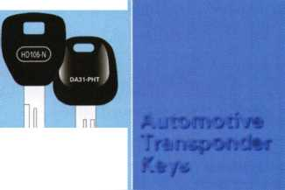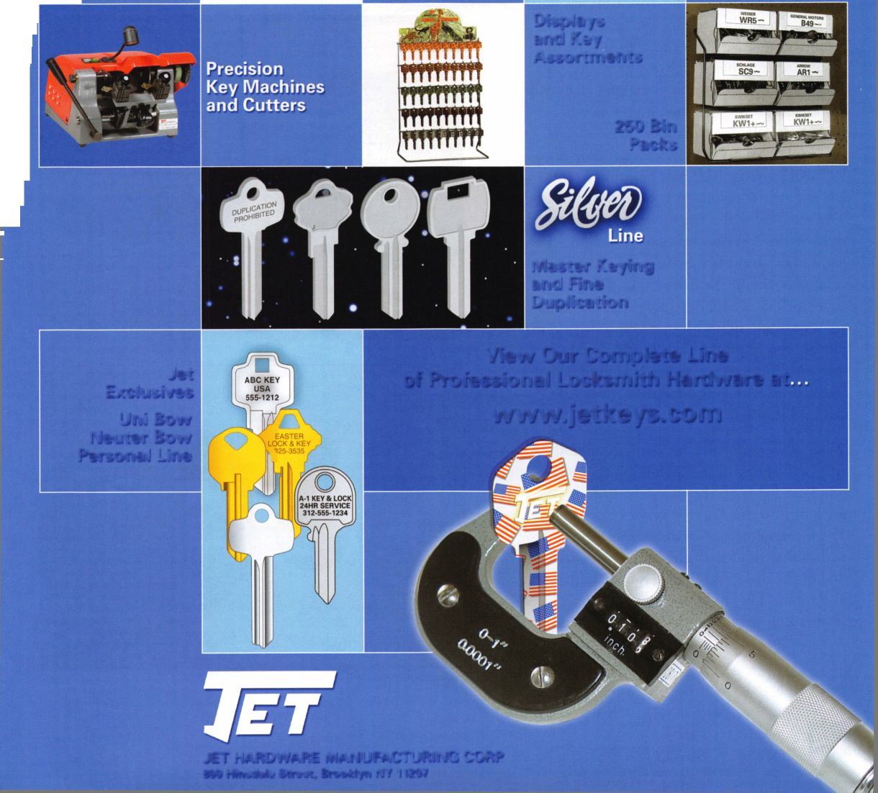

The dialing sequence for this lock is four times left to the first number; three times right to the second number; two times left to the third number; then differently from most other locks. The ending sequence begins with turning the dial right to Zero then turn the turn knob in the center of the dial and then continue turning the dial right to the stop. This is how this lock adds manipula­tion resistance to give it the Group 1 rating. How does this affect the dial? First let’s look at the S&G 6730 lock and drive cam. Currently the dials for this lock are manufac­tured with the spline groove aligned with the 50 mark on the dial. The drive cam has four spline grooves allowing for the lock to be mounted in any of four directions. The four directions are labeled RH or right hand, LH or left hand, VU or vertical up, and lastly VD or vertical down. The handing is viewed from the backside of the lock. This means with the door locked that a lock mounted RH will have the lock bolt pointing to the left as you are looking at it from the outside. The standard dial is manufactured with the spline groove in one location. Changing the hand is accomplished by using the different spine grooves on the drive cam. The 8400 series lock uses a unique drive cam that only allows for one spline groove. Both drive cams can be seen in photo 10. Using a standard dial with this lock requires stocking four dif­ferent dials. A Centispline dial can be changed in the field to the appropriate hand.

What is the difference between a standard and Centispline dial? Look at photo 10 the standard dial is on the left. The spindle is press fit into the dial and is not changeable. The Centispline shown disassembled in photo 11 has the addition of the hub on the under­side of the dial. This hub has outside threads like a nut. The spindle is pressed into a smaller hub with gear teeth on the outside

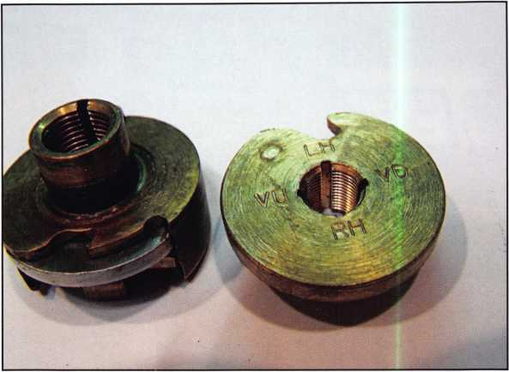

Photo 9

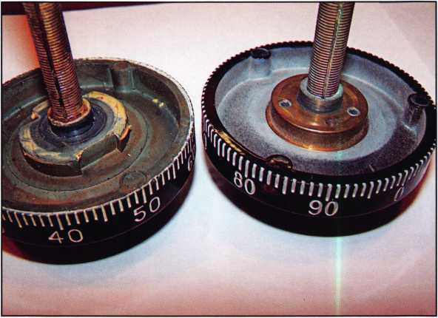

Photo 10

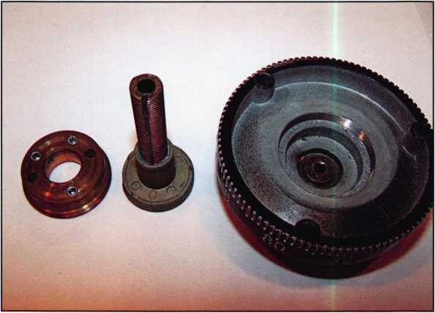

Photo 11

Keynotes • January 2007

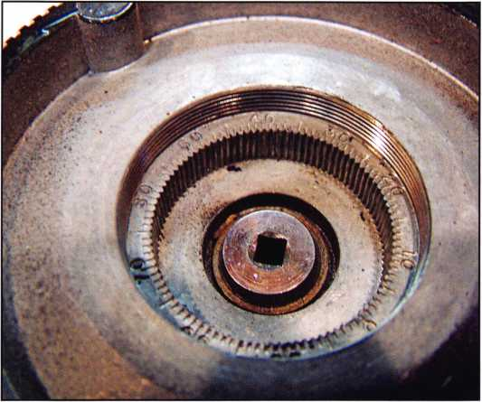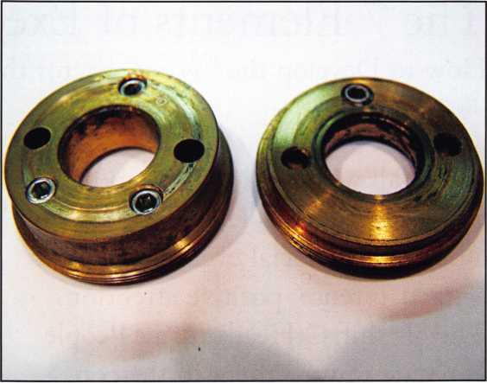

Photo 1 2

Photo 13

circumference that mate with the underside of the dial. The spindle hub has a mark in line with the spline groove. It is inserted into the underside of the dial that has a matching set of dial numbers seen in photo 12 at the appropriate location for the mounting direction of the lock. The unique thing about this design is the lock could be mounted any direction including on a diagonal with the same ending sequence. The common locations for the four hands are RH at 38, LH at 88, VU at 63 and VD at 13. Any location can be selected though if the lock is mounted on a diagonal making this style of dial very versatile. Photo 13 shows the difference between the old and new style dial hub. The old style

uses only one set screw to keep it from unscrewing.

The new style uses three set screws. I expected to find the old style hub with a loose set screw on the underside of the dial.

Sometimes your best guess to the problem will not be the reason for the call. Although this dial was not a Centispline it still was loose on the spindle and needed to be replaced in addition the lock was replaced to cor­rect the problem with the combination not dialing cor­rectly ever time. Taking extra parts and being prepared is always wise.



Keynotes • January 2007

The 7 Elements of Executive Presence:

How to Develop the “Wow” Factor that Makes Great Leaders Stand Out

By: Suzanne Bates

We’ve all witnessed that moment when someone walks into a room at a business or social event and attracts intense, positive attention. The air shifts. Heads turn. People gravitate toward them in the con­versation circle. In short, they have a “wow” factor.

The wow factor is often called “executive presence.”

It is easy to see and yet hard to define. But it’s important to develop because when you have it, peo­ple want to promote you, do business with you, give you better assignments, and recommend you to oth­ers.

Is executive presence in your DNA or can you learn it? It turns out you’re not born with this skill. And it’s not as much of a mystery as you might think. It is a blending of competencies and skills that when com­bined, send all the right signals.

Executive presence creates a strong personal brand. The brand is the message or impression that comes to mind when people see you, hear of you or think about you. In business, you need to build your brand with everyone - your colleagues, boss, direct reports, clients or customers; because it’s impossible to meet and know everyone well. Brand gives you word of mouth that is a tremendous advantage.

Executive presence isn’t just fluff, and it isn’t about first impressions; it is a thought or feeling about you that develops over time based on other people’s expe­riences with you. When you do it right, you build trust, which creates word of mouth or buzz that opens up business opportunities and creates professional and financial success.

So how do you start developing a powerful executive presence and create your own personal brand? There are seven elements of executive presence:

1. Substance
2. Personal Style
3. Physical Presence
4. Vocal Skill
5. Manners/Etiquette
6. Receptivity/Listening
7. Work Space #1. Substance

The most important aspect of executive presence is the ability to communicate substance. You are an expert in your field, and you need to share that expertise in a powerful way. In order to do this you need to develop a high level of skill in speaking, pre­senting, writing and communicating your ideas. You may be one of the most knowledgeable people in your industry, however, if you cannot convey your business and technical skill, you won’t get the recognition you deserve.

#2. Personal Style

We can hope that it doesn’t matter, but the way we dress speaks volumes about us as professionals. Your business attire should make you feel confident and powerful every single day. Think about how you feel when you put on your best suit. You should walk in the door feeling like that every day. Polished personal style isn’t just about the clothing you wear; it’s about how you feel in those clothes.

**30**

Keynotes • January 2007

**WE ARE LISTENING TO YOUR NEEDS!**

**GET READY. CHANGE IS  
AROUND THE CORNER!**

Take a LOOK at some of the new things ALOA has planned for YOU in 2007.

ALOA is excited about the new changes in-store for everyone in 2007. For this membership cam­paign we have listened to the membership and are rapidly making changes to suit your needs.

• Don’t miss out as we roll out our new & improved Keynotes magazine introducing such interactive features as a Q&A section exclusively for members.

More user-friendly ALOA website.

• More training & education opportunities.

• Better and broader network possibilities.

• ALOA store with more books & better merchandise; NEW products that help YOUR bottom line.

• RENEW TODAY to become eligible for great prizes including an exciting 7-day cruise!

*,/jjn*

ALOA offers you the strength of over 8.000 leading  
firms & individuals. ALOA is YOUR voice in the  
industry. ALOA represents the collective interests  
of the association to the press, government, and  
the public. ALOA is able to open many doors need  
ed for your success in our ever-changing industry

CONTACT:

Associated Locksmiths of America 3500 Easy Street Dallas, TX 75247

Phone 800-532-2562 • Fax 214-819-9736 • [www.aloa.or](http://www.aloa.or)

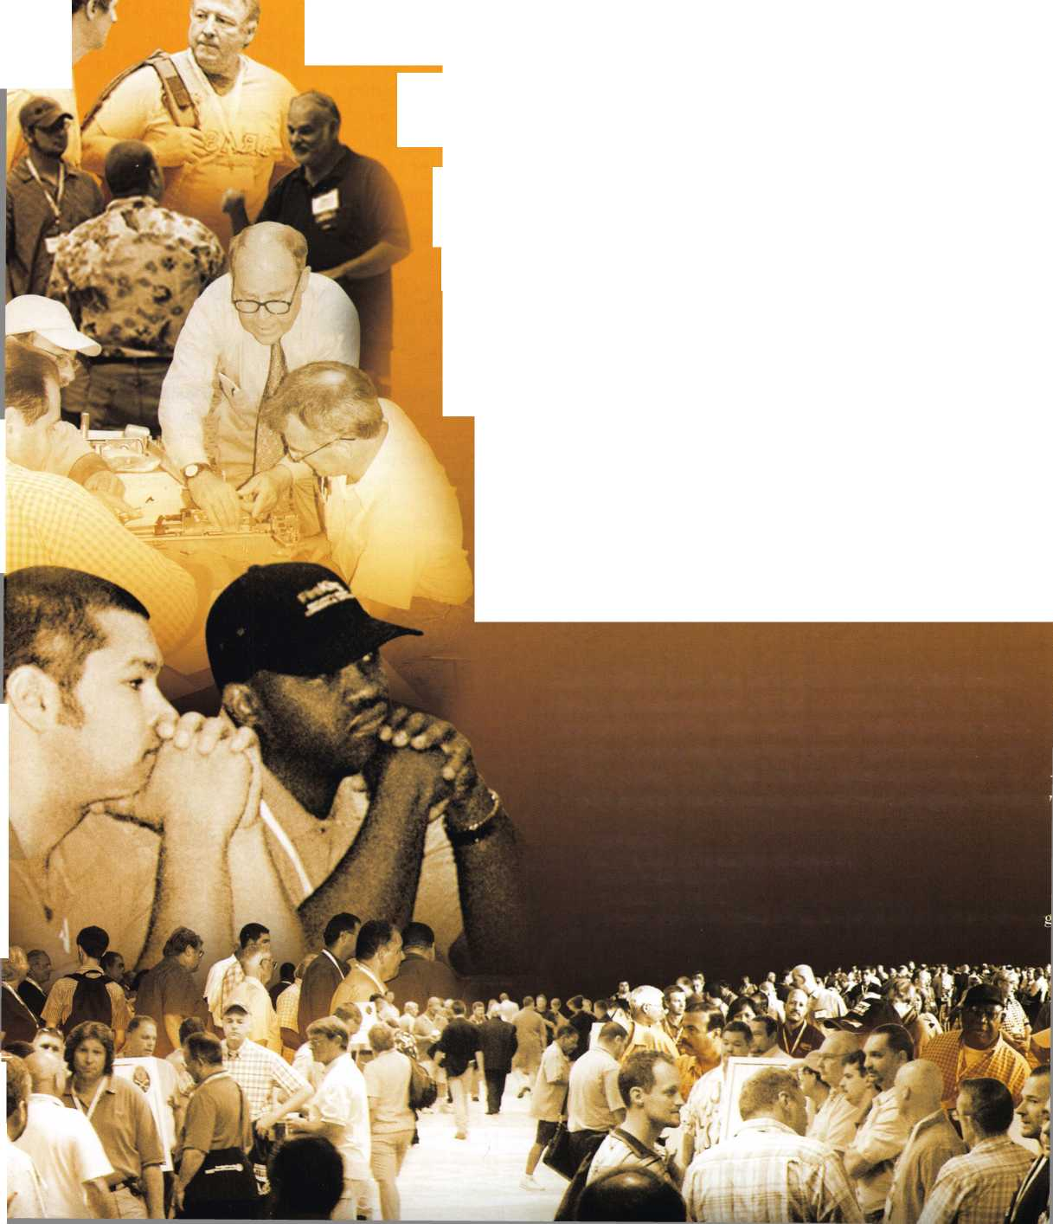

#3. Physical Presence

Your physical presence is more than your body lan­guage. It’s your confidence, spirit, and energy.

People are reading your body language 24/7. Learn to sit, stand, walk, move and gesture purposefully. It says so much about your professionalism.

#4. Vocal Skill

Many people know us only by the sound of our voice. Yet the voice is one of the most overlooked aspects of executive presence. Knowing how to use your voice effectively is one of the secrets to standing out in the crowd. Your voice should be conversational and clear. It should demonstrate your confidence, enthusiasm, passion and intelligence. Add interest to your voice by using inflection, varying the pace, emphasizing important words or phrases and pausing when you make an important point.

#5. Manners/Etiquette

It sounds like a no-brainer, but business etiquette is essential to professional presence. Etiquette is easy if you remember a few things; treat others as you want to be treated, put their comfort ahead of your own, and be gracious and grateful to everyone you meet. People may not comment on your manners but they do notice and assume you fit in perfectly.

#6. Receptivity/Listening

Listening is a leadership skill. Those who listen stand out and are remembered. Listening includes being accessible, encouraging people to express themselves, listening with mindfulness, not speaking too much, and using verbal and non verbal language to convey genuine interest in the other person. If you don’t know whether you’re a good listener, ask someone who will tell you the truth.

#7. Work Space

Your work space is an extension of you and can be a tip off to others about how you really conduct busi­ness. Many people with a messy office believe it shouldn’t matter. As much as we wish no one will see or notice, that’s not true. A CEO once said he decides whether to promote his people based on “clut­ter.” Clear it out, find a home for everything, keep electronic files of most documents, and then make it an attractive space for you and others. This is not only important to your image; it will also help you feel better about your hours at work.

Now, where do you start? Choose one of the ele­ments and get started. Ask a trusted advisor to help. Soon, people will be gravitating to your circle when you walk into the room.

About the Author:

Suzanne is a prominent executive coach and communications con­sultant who has perfected the art of corporate communication.

She is the President and CEO of Bates Communications, which helps executives and professionals develop a unique and authentic communication style to become stars in their industries. Suzanne is the author of “Speak Like a CEO: Secrets to Commanding Attention and Getting Results.” For more information, please visit [www.bates-communications](http://www.bates-communications) or call **800**-**903**-**8239**.

**32**

Keynotes • January 2007

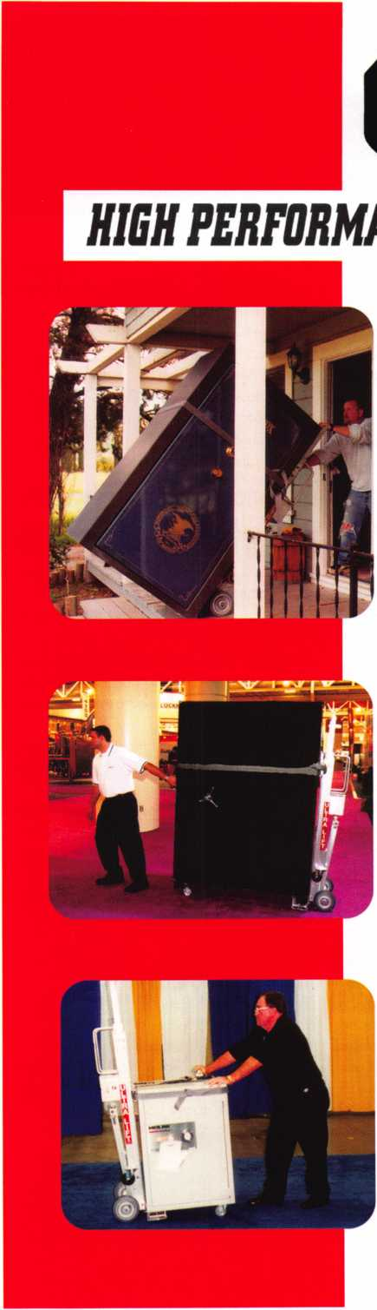

***OPERATOR SAFETY***

Injuries can be virtually eliminated. Ultra Lift does the lift­ing so that operator effort required to complete a move is minimized. Heavy loads are broken back with ease. The operator stays in control by using a combination of motor power, balance and leverage in every phase of a move.

***REDUCE LABOR COSTS***

Fewer people are required for any move with Ultra Lift. Manpower can be scheduled more productively. Labor savings often pay for the Ultra Lift in one month.

***ELIMINATE DAMAGE***

Loads are broken back, set down and moved under power with maximum leverage and operator control. Gentle handling eliminates bumps, bounces and damage to the load and premises.

***INCREASE PROFITS***

Increased operator safety, reduced labor cost and elimina­tion of damage to the load and premises all contribute to significant increases in profits.

FOR LITERATURE, VIDEO OR ON-SITE DEMONSTRATION, WRITE OR CALL:

ULTRA LIFT CORPORATION

475 STOCKTON AVENUE, UNIT E SAN JOSE, CA 95126 800-346-3057 408-287-9400 FAX 408-297-1199 E-mail: [info@ultralift.com](mailto:info@ultralift.com) **[www.ultralift.com](http://www.ultralift.com)**

U.S. PATENT 4.570.953

ULTRA LIFT supplies the power - so you don't have to. One person can safely and easily handle loads that usually require 2 or 3 people, even up or down stairs. Two people can handle most safes to 1500 pounds. If safety is your concern, ULTRA LIFT is the best move you'll ever make!

**Classifieds**

EMPLOYMENT

LOCKSMITH TECHNICIANS WANTED

In-house locksmith with experience road and shop work for commercial, safe and access control service. Salary plus benefits. See website or call for details. 713-755- 5906. Apply in person at 1310 Prairie, 2nd floor, Houston, Texas 77002. [www.co.harris.tx.us/hrrm/](http://www.co.harris.tx.us/hrrm/)

Employment.htm

LOCKSMITH WANTED

Locksmith wanted at Lee's Lock & Safe in Encinitas, California! Commerical, Residential, Electronic Access Control & Safes a plus. Fast paced and good bene­fits. Located in beautiful North Coastal San Diego County. In business since 1970.

Fax: 760-753-5851,

Ph: 760-753-0825.

LOCKSMITH WANTED

South King County Locksmith Company (locations in SeaTac and Federal Way) needs inside locksmiths as well as outside technicians. Top benefits package and top pay. Medical, 40IK, paid vacation and plenty of opportunity for advancement. We will supply everything you need (tools, truck, uniform)> Please email or fax resume to: [paulbrandon@lockguys.com](mailto:paulbrandon@lockguys.com) or give me a call at 253-261-3870.

30819 Pacific Highway South Federal Way, WA 98003

LOCKSMITH WANTED

Busy shop in Woburn, Massachusetts seeks experienced Locksmith. We perform com­mercial, residential, safe, glass storefronts, card access, and automotive work includ­ing 2 AAA accounts. You don't have to know all these phases of locksmithing and

we are also willing to train if interested. Sub-contractors welcome - Your van or ours. For more info please contact John at 781-933-9999 or send resume to: Locks & Keys, Inc. P.O. Box 222, Woburn, MA 01 801. Thank you for your consideration.

RELOCATE TO ALASKA

Action Security, Inc is a 44 year old securi­ty company that is interested in hiring you. It's services include electronic security, bank/credit union security; wholesale prod­ucts; hollow metal fabrication; contract hardware; retail security centers; and pro­fessional locksmith services. We have three retail locations and offer statewide services. We currently are in need of locksmiths, safe technicians, AHC's, CDC's, EHC's, electron­ic and bank technicians. Opportunity and professional growth is encouraged. Ideal candidate must be neat in appearance, people oriented, self motivated and hard working. Applicants must possess a good driving record, pass background and drug testing. We will train the right candidate. Action offers full benefits package; competi­tive wages; medical insurance; paid vaca­tion and sick days, continuous education and profit sharing. Please email resume to: [info@actionsecurity.com](mailto:info@actionsecurity.com)

LOCKSMITH WANTED

A southern California locksmith company is looking for an honest, dependable, reliable and experienced locksmith. The company has been in business for 30 years and is looking for a locksmith to work both commericial and residential. Salary and commission, plus gen­eral insurance, paid vacation and 401K.

Fax resume to: 760-779-1 811.

EXPERIENCED LOCKSMITH

Established company in Central Virginia is looking for a locksmith experienced in com­mercial, residential and automotive. Great pay, insurance, retirement plan, paid vaca­

tion and holidays. Needs to be motivated team player. Drug test, background check, good driving record required.

Send resume to:

Albermarle Lock & Safe Co.

51 3 A Stewart Street Charlotesville, VA 22902 Attention: Scott Mega ha n Fax. 434-971-8021 email: [alb.lock@yahoo.com](mailto:alb.lock@yahoo.com)

INVENTORY CONTROLLER WANTED

Inventory Controller wanted at Liberty Lock and Safe in Las Vegas! Inventory experi­ence and hardware knowledge required. Call James at 702-284-5404

WANTED

Qualified locksmith with at least five years experience. In shop and on the road serv­ice. Combination changing, deposit box opening and servicing, installations. Impression, rekey and master key commer­cial and residential locks. Abloy, Me deco, Everest, llco Kaba high security locks. Knowledge and experience in opening and servicing safes. Reliable with sound team player skills. Applicant must be willing to relocate to Bermuda. Paid vacation, holi­days, major medical insurance, pension, tools, uniform provided.

Respond to:

Fax: 1-508-366-8864

Email: [barnes-lock@ibl.bm](mailto:barnes-lock@ibl.bm)

Barnes Locksmith Service

P.O. Box HM 636

Hamilton HM CX, Bermuda

Applications who have tried responding to

email address in Nov/Dec issues should

resend to the above corrected email

address.

Keynotes • January 2007

EMPLOYMENT OPPORTUNITY

Locksmith - Entry Level/Experienced - A true career opportunity in Las Vegas for enthusias­tic and dependable people! A&B Security Group is seeking entry level or experienced locksmiths to join our dynamic and growing security services organization. On the job training and advancement opportunities into many areas such as alarms, CCTV, access control systems, safes and more. Join the A&B Security Group team and receive competitive salary and excellent benefits which include: Minimum first year salary $30,000, 401K, hospitalization package, paid holidays, com­pany vehicles, even a relocation allowance! A&B Security Group is currently accepting applications from interested and qualified candidates to fill the open Locksmith posi­tions. Come work for A&B Security Group in Las Vegas and you'll stay in Las Vegas! Apply on our website [www.227lock.com](http://www.227lock.com) or call 702-227-LOCK and ask for Phil today!

WANTED TO BUY/SELL

BUSINESS FOR SALE

Sacramento, California Locksmith Business with two fully equipped vans, full inventory, tools, keys and code machines, etc. Established customer base since 1976, leased store in shopping center. Contact Walter Marcotte, owner, Jeff's Locksmiths. Lie# 706234 2377 Arden Way, Sacramento California 95825.

Fax 916-929-5945 Phone 530-674-3411 Randy's Cell Phone 916-600-1557

FOR SALE

Original Curtis key blanks.

Dan Barrow 601-624-8185.

FOR SALE - ALL ITEMS LIKE NEW! PRIMUS Demo kit with lock out cylinder - $125. Everest Demo kit - $125. Schlage Finish samples - $15. Solid Oak Mount #44-112 - $50. Single mount composite material - $25. Sold individually or best offer for all. Contact John L. Kish.

Telephone 412-400-5900 Email: [kishjohn@softhome.net](mailto:kishjohn@softhome.net)

FOR SALE

Many new and gently used Omnilock OM and OP 2000 locks. For prices and more information, please email [Omnilocksforsale@aol.com](mailto:Omnilocksforsale@aol.com) or fax 860-346-6667

BUSINESS FOR SALE

Turnkey locksmith company incorporated. All inventory and equipment, new $10,000 computerized system, domain name, phone lines & vehicles. Prime loca­tion since 1979. High foot & return client business. Loyal employees, customer base includes national retail chains. Alarm and proprietary key systems assures repeat business. Grow in a vibrant area in Seattle, Washington, where new construc­tion projects abound. Call Verlayn McManus, RE/MAX Northwest at 1-866-733-5788 or send email to [vmc- manus@remax.net](mailto:vmc-manus@remax.net).

LOCKSMITH BUSINESS FOR SALE

Growing East Tennesse locksmith business established 1987. Supports three lock­smiths with two fully equipped vans serving residential & commercial accounts as well as walk-in customers. Business located in a **1152** sq.ft, concrete building on a 7500 sq.ft, corner lot fronting main hwy. Complete set up $225,000. Call 423-586- **3101** M-F 8-5.

EQUIPMENT FOR SALE

•1 llco 009 Tubular Key Machine, 120 Volt - $200

* 1 llco Exacta Punch Setup for Kwikset 5 & 6 Pin - $200
* 1 Framan #2 Code Machine 12 Volt -

$1200

* 1 Framan Express 12 Volt - $800

All prices plus shipping. 732-773-6447 or email: [ils245@comcast.net](mailto:ils245@comcast.net)

BUSINESS FOR SALE

Storefront and mobile services established for 24 years. Located in Southeast Kentucky. We serve several counties. We are now the only locksmith company in our town. With limited competition in area. We will include 2 fully equipped vans, many contracts, systems and inventory. Good

location to raise a family, retire or escape the high pressure life. We have a good growth potential. Asking $65K or best offer. Selling due to personal reasons. Contact us at [sbvbky30@hotmail.com](mailto:sbvbky30@hotmail.com). Serious inquiries only.

MOBILE BUSINESS FOR SALE IN MIAMI, FLORIDA

15 year old, well established business.

90% commercial. Very good accounts. 2000 Ford Econoline Van .75 ton, HPC 1200, HPC 9160, all pinning kits, blanks, hand tools and stock included. $190,000. Also HPC 1200 blitz, 6 months old, 30 min use, $1,000.

Call Brad 305-233-4447

BUSINESS FOR SALE

In Brandon, Florida. Two fully equipped service vans, safe chariot, electro-truck. Matrix machine, SDD machine, all other key machines, inventory and stock.

Business has been around for 31 years with potential for growth. 200K in sales per year minimum. 160K asking price.

Call 813-363-7949 for more details. SERIOUS INQUIRIES ONLY!

MOBILE LOCKSMITH BUSINESS FOR SALE

Owner retiring after 28 years due to health. Many commercial and auto accounts in Chicago and surrounding area. Includes 2003 Dodge Sprinter, ultra code Triax, Bravo key machine, HPC 1200 T-code, RW2 w/tex code Triax, Bravo key machine, HPC 1200 T-code, RW2 w/tex code, NG5, car opening tools and all stock. $145,000 firm. For further information call 1-708-422-4808.

RETIRING EQUIPMENT

Like NEW. Package deal only. 1 High Tech Lockout Kit, 1200 Blitz HPC, 3333 Trace- A-Key, HPC PCH 14, Hand tools, Key Blanks, 16 determinators, pick sets, key pegs, 11 auto tryout key sets, 19K NEW, MAKE OFFER. [Chevieman@aol.com](mailto:Chevieman@aol.com) or call 602-291-3500.

Classified Advertising Policy

Classified advertising space is provided free of charge to ALOA members and for a fee of $2.00 per word, $40.00 minimum for non members. Classified ads may be used to advertise used merchandise and overstocked items for sale, "wanted to buy" items, business opportunities, employment opportunities/positions wanted and the like. Members or non members wishing to advertise services or new merchandise for sale may purchase a "Commercial Classified Ad" for a fee of $4.00 per word with a minimum of $100.00. Each ad will run for two issues. For blind boxes there is a $10.00 charge for members and non members. All ads must be submitted in writing to the Advertising Sales Department via fax at 817-645-7599 or through an email to [adsales@aloa.org](mailto:adsales@aloa.org) by the fifteenth of the month two months prior to issue date. ALOA reserves the right to refuse any classified advertisement that it deems inappropriate according to the stated purpose of the classified advertising section.

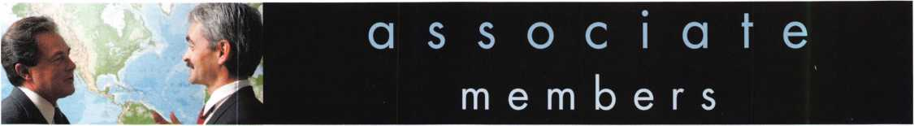

Distributor

**1 st In Hardware, Inc.**

Phone: Phone: 410-646-9900 Fax: 410-646-0045 www. 1 stinhardware.com

**ADEL Fingerprint Technology, LLC**

Phone: 909-595-1222 Fax: 909-595-1667

**Accredited Lock Supply Co.**

Phone: 800-652-2835 Fax: 201-865-2435 [www.acclock.com](http://www.acclock.com)

**American Auto Lock.Com**

Phone: 717-392-6333 Fax: 717-581-8353 [www.americanautolock.com](http://www.americanautolock.com)

**Andrews Wholesale Lock Supply**

Phone: 717-272-7422 Fax: 717-274-8659 [www.andrewslock.com](http://www.andrewslock.com)

**Boyle & Chase Inc.**

Phone: 800-325-2530 Fax: 800-205-3500 [www.boyleandchase.com](http://www.boyleandchase.com)

**Clark Security Products**

Phone: 858-974-6740 Fax: 858-974-6720 [www.clarksecurity.com](http://www.clarksecurity.com)

**Cook's Building Specialties**

Phone: 505-883-5701 Fax: 505-883-5704

**Dire's Lock & Key Company**

Phone: 303-294-0176 Fax: 303-294-0198

**Direct Security Supply, Inc.**

Phone: 800-252-5757 Fax: 800-452-8600

**Discount Key Machines.Com/Busch**

Phone: 800-332-8724 Fax: 407-363-4666

**Doyle Security Products**

Phone: 800-333-6953 Fax: 612-521-0166 [www.doylesecurity.com](http://www.doylesecurity.com)

**Dugmore and Duncan, Inc.**

Phone: 888-384-6673 Fax: 888-329-3846

**E. L. Reinhardt Co., Inc.**

Phone: 800-328-1311 Fax: 651-481-0166 [www.elreinhardt.com](http://www.elreinhardt.com)

**Ewert Wholesale Hardware**

Phone: 800-451-0200 Fax: 708-597-0881

**Foley-Belsaw Company**

Phone: 800-821-3452 Fax: 816-483-5010 [www.foley-belsaw.com](http://www.foley-belsaw.com)

**Fried Brothers Inc.**

Phone: 800-523-2924 Fax: 215-592-1255 [www.fbisecurity.com](http://www.fbisecurity.com)

**H.L. Flake Co.**

Phone: 800-231-4105 Fax: 713-926-3399 [www.hlflake.com](http://www.hlflake.com)

**Hans Johnsen Company**

Phone: 214-879-1550 Fax: 214-879-1530 [www.hjc.com](http://www.hjc.com)

**Hardware Agencies, Ltd.**

Phone: 416-462-1921 Fax: 416-462-1922 [www.hardwareagencies.com](http://www.hardwareagencies.com)

**IDN Incorporated**

Phone: 817-421-5470 Fax: 817-421-5468 [www.idn-inc.com](http://www.idn-inc.com)

**Instant Hardware Delivery, Inc**

Phone: 800-355-1 107 Fax: 800-663-8518

**Intermountain Lock & Supply**

Phone: 800-453-5386 Fax: 801-485-7205 [www.intermountainlock.com](http://www.intermountainlock.com)

**International Electronics, Inc**

Phone: 800-343-9502 Fax: 617-821-4443

**Jo Van Distributors**

Phone: 416-288-6306 Fax: 416-752-8371 [www.jovanlock.com](http://www.jovanlock.com)

**L V Sales Inc**

Phone: 323-661-4746 Fax: 323-661-1314 [www.lvsales.com](http://www.lvsales.com)

**Lockmasters, Inc.**

Phone: 859-885-6041 Fax: 859-885-7093 [www.lockmasters.com](http://www.lockmasters.com)

**Locks Company**

Phone: 800-288-0801 Fax: 305-949-3619

**Locksmith Ledger International**

Phone: 847-454-2700 Fax: 847-454-2759 [www.lledger.com](http://www.lledger.com)

**McDonald Dash Locksmith Supply**

Phone: 800-238-7541 Fax: 901-366-0005 [www.mcdonalddash.com](http://www.mcdonalddash.com)

**Monaco Lock Co.**

Phone: 800-526-6094 Fax: 800-845-5625 [www.monacolock.com](http://www.monacolock.com)

**NLS Lock Supply Dba Nevada Lock S**

Phone: 702-737-0500 Fax: 702-737-7134

**Omaha Wholesale Hardware**

Phone: 800-238-4566 Fax: 402-444-1664 [www.omahawh.com](http://www.omahawh.com)

**Phoenix Safe International LLC**

Phone: 765-483-0954 Fax: 765-483-0962 [www.phoenixsafeusa.com](http://www.phoenixsafeusa.com)

**Positive Identity Solutions**

Phone: 704-663-1175 Fax: 704-660-1301 [www.pids-usa.com](http://www.pids-usa.com)

**RA-Lock Company**

Phone: 972-775-6301 Fax: 972-775-6316 [www.ralock.com](http://www.ralock.com)

**Security Distributors Inc**

Phone: 800-333-6953 Fax: 612-524-0166

**Security House**

Phone: 905-669-5300 Fax: 905-660-6313 [www.securityhouselock.com](http://www.securityhouselock.com)

**Southern Lock and Supply Co.**

Phone: 727-541-5536 Fax: 727-544-8278 [www.southernlock.com](http://www.southernlock.com)

**Stone & Berg Wholesale**

Phone: 800-225-7405 Fax: 800-535-5625

**Streetwise Security Products**

Phone: 252-830-5577 Fax: 252-830-5542

**The Locksmith Store Inc.**

Phone: 847-364-5111 Fax: 847-364-5125 [www.locksmithstore.com](http://www.locksmithstore.com)

**Timemaster Inc.**

Phone: 859-259-1878 Fax: 859-255-0298 [www.time-master.com](http://www.time-master.com)

**Top Notch Distributors, Inc.**

Phone: 800-233-4210 Fax: 800-854-4146 [www.topnotch.bz](http://www.topnotch.bz)

**Turn 10 Wholesale**

Phone: 800-848-9790 Fax: 800-391-4553

**U.S. Lock Corp.**

Phone: 800-925-5000 Fax: 800-338-5625 [www.uslock.com](http://www.uslock.com)

**Wilson Safe Company**

Phone: 215-492-7100 Fax: 215-492-7104 [www.wilsonsafe.com](http://www.wilsonsafe.com)

Manufacturer

**A & B Safe Corporation**

Phone: 800-253-1267 Fax: 856-863-1208 [www.a-bsafecorp.com](http://www.a-bsafecorp.com)

**ABUS Lock Company**

Phone: 800-352-2287 Fax: 602-516-9934 [www.abus.com](http://www.abus.com)

**Access Security Products Ltd.**

Phone: 905-337-7874 Fax: 905-337-7873 [www.access-safe.com](http://www.access-safe.com)

**Adams Rite Mfg Company**

Phone: 800-872-3267 Fax: 800-232-7329 [www.adamsrite.com](http://www.adamsrite.com)

**Adesco Safe Mfg. Company**

Phone: 800-694-9340 Fax: 562-408-6427 [www.adesco.com](http://www.adesco.com)

**Adrian Steel Company**

Phone: 800-677-2726 Fax: 517-265-5834 [www.adriansteel.com](http://www.adriansteel.com)

**Advanced Diagnostics USA Inc**

Phone: 650-876-2020 Fax: 650-876-2022 [www.autokeys.com](http://www.autokeys.com)

**Alarm Controls Corporation**

Phone: 631-586-4220 Fax: 631-586-6500 [www.alarmcontrols.com](http://www.alarmcontrols.com)

**All Five Tool Company, Inc.**

Phone: 860-583-1691 Fax: 860-583-4516 [www.all5tool.com](http://www.all5tool.com)

**American Security Products**

Phone: 909-685-9680x2013 Fax: 909-685-9685 [www.amsecusa.com](http://www.amsecusa.com)

**BWD Lockcraft**

Phone: 973-728-3707 Fax: 973-728-3731 [www.bwdautomotive.com](http://www.bwdautomotive.com)

**Bianchi USA, Inc.**

Phone: 800-891-2118 Fax: 216-803-0202 [www.bianchi](http://www.bianchi) 1770usa.com

**Buddy Products**

Phone: 312-733-6400 Fax: 312-733-8356 [www.buddyproducts.com](http://www.buddyproducts.com)

**CCL Security Products**

Phone: 800-733-8588 Fax: 847-537-1800 [www.cclsecurity.com](http://www.cclsecurity.com)

**CompX Security Products**

Phone: 864-297-6655 Fax: 864-297-9987 [www.compxnet.com](http://www.compxnet.com)

Keynotes • January 2007

associate

members

**D&D Technologies (USA), Inc.**

Phone: 714-677-1300x292 Fax: 714-677-1299 [www.ddtechglobal.com](http://www.ddtechglobal.com)

**DETEX Corp.**

Phone: 800-729-3839 Fax: 830-620-671 1 [www.detex.com](http://www.detex.com)

**Don-Jo Manufacturing, Inc.**

Phone: 978-422-3377 Fax: 978-422-3467 [www.don-jo.com](http://www.don-jo.com)

**Door Controls International**

Phone: 800-742-3634 Fax: 800-742-0410 [www.doorcontrols.com](http://www.doorcontrols.com)

**Door Jamb Armor**

Phone: 201-490-5381 Fax: 201-490-5389 [www.djarmor.com](http://www.djarmor.com)

**Doorking Inc.**

Phone: 800-826-7493 Fax: 310-641-1586 [www.doorking.com](http://www.doorking.com)

**Dorma Architectual Hardware**

Phone: 717-336-3881 Fax: 717-336-2106 [www.dorma-usa.com](http://www.dorma-usa.com)

**E-Lock USA**

Phone: 434-589-5913 Fax: 434-589-3738 [www.e-lock-usa.com](http://www.e-lock-usa.com)

**FireKing Security Products**

Phone: 800-457-2424 Fax: 800-896-6606 [www.fkisecuritygroup.com](http://www.fkisecuritygroup.com)

**Framon Manufacturing Company Inc.**

Phone: 989-354-5623 Fax: 989-354-4238 [www.framon.com](http://www.framon.com)

**G-U Hardware Inc.**

Phone: 757-877-9020 Fax: 757-877-9720 [www.g-u.com](http://www.g-u.com)

**HPC, Inc.**

Phone: 847-671-6280 Fax: 847-671-6343 www. h pc world .com

**HY-KO Products Co.**

Phone: 330-467-7446 Fax: 330-467-7442

**Hammerhead Industries, Inc.**

Phone: 805-658-9922 Fax: 805-658-8833 [www.gearkeeper.com](http://www.gearkeeper.com)

**Ingersoll Rand Security Technologies**

Phone: 317-805-5713 Fax: 317-805-5779 [www.schlagelock.com](http://www.schlagelock.com)

**Jackson Corporation**

Phone: 323-269-8111 Fax: 800-888-6855 [www.jacksonexit.com](http://www.jacksonexit.com)

**Jet Hardware Mfg., Co.**

Phone: 718-257-9600 Fax: 718-257-0973 [www.jetkeys.com](http://www.jetkeys.com)

**KABA ILCO Corp.**

Phone: 252-446-3321 Fax: 252-446-4702 [www.kaba-ilco.com](http://www.kaba-ilco.com)

**KEY-BAK/West Coast Chain Mfg.**

Phone: 909-923-7800 Fax: 909-923-0024 [www.keybak.com](http://www.keybak.com)

**Kenstan Lock Company**

Phone: 516-576-9090x315 Fax: 516-576-0100 [www.kenstan.com](http://www.kenstan.com)

**Keri Systems Inc.**

Phone: 408-451-2520 Fax: 408-441-0309 [www.kerisys.com](http://www.kerisys.com)

**Knaack Manufacturing Co.**

Phone: 800-456-7865 Fax: 815-459-9097 [www.weatherguard.com](http://www.weatherguard.com)

**Kustom Key Inc.**

Phone: 800-537-5397 Fax: 800-235-4728

[www.kustomkey.com](http://www.kustomkey.com)

**LAB Security**

Phone: 800-243-8242 Fax: 860-583-7838 [www.labpins.com](http://www.labpins.com)

**La Gard Inc.**

Phone: 310-325-5670 Fax: 310-325-5615 [www.lagard.com](http://www.lagard.com)

**Lock America, Inc. dba L.A.I. Group**

Phone: 714-373-2993 Fax: 714-373-2998 [www.laigroup.com](http://www.laigroup.com)

**LockPicks.Com/Brockhage Tools**

Phone: 408-437-0505 Fax: 408-516-9642

**Lucky Line Products, Inc.**

Phone: 858-549-6699 Fax: 858-549-0949 [www.luckyline.com](http://www.luckyline.com)

**M.A.G. Manufacturing**

Phone: 714-891-5100 Fax: 714-892-6845 [www.magmanufacturing.com](http://www.magmanufacturing.com)

**MUL-T-LOCK USA, Inc.**

Phone: 800-562-3511 Fax: 973-778-4007 [www.mul-t-lockusa.com](http://www.mul-t-lockusa.com)

**Major Mfg, Inc.**

Phone: 714-772-5202 Fax: 714-772-2302 [www.majormfg.com](http://www.majormfg.com)

**Maxcess Card Systems Ltd**

Phone: 949-492-5964 Fax: 949-492-0415 [www.maxcess-card.com](http://www.maxcess-card.com)

**Medeco Security Locks**

Phone: 540-380-5000 Fax: 540-380-5010 [www.medeco.com](http://www.medeco.com)

**Mil-Comm Products Co Inc**

Phone: 201-935-8561 Fax: 201-935-6059

**Promet Safe Inc.**

Phone: 860-436-6246 Fax: 860-436-6876 [www.promet-safe.com](http://www.promet-safe.com)

**Protex Safe Co., LLC**

Phone: 818-610-8030 Fax: 818-610-8004 www. p rotexsa fe. com

**ROFU International Corp.**

Phone: 253-922-1 828 Fax: 253-922-7272 [www.rofu.com](http://www.rofu.com)

**Rutherford Controls Int'l Co.**

Phone: 519-621-7651 Fax: 519-621-7939 [www.rutherfordcontrols.com](http://www.rutherfordcontrols.com)

**STRATTEC Security Corp.**

Phone: 414-247-3333 Fax: 414-247-3564 [www.aftermarket.strattec.com](http://www.aftermarket.strattec.com)

**Sargent & Greenleaf, Inc.**

Phone: 859-885-941 1 Fax: 859-885-3063 [www.sargentandgreenleaf.com](http://www.sargentandgreenleaf.com)

**Sargent Manufacturing Co.**

Phone: 800-727-5477 Fax: 888-863-5054 [www.sargentlock.com](http://www.sargentlock.com)

**Schwab Corp.**

Phone: 765-447-9470 Fax: 765-447-8278 [www.schwabcorp.com](http://www.schwabcorp.com)

**Securifort Inc**

Phone: 819-359-2226 Fax: 819-359-2218 [www.securifort.com](http://www.securifort.com)

**Securitron Magnalock Corp.**

Phone: 775-355-5625 Fax: 775-355-5636 [www.securitron.com](http://www.securitron.com)

**Security Door Controls**

Phone: 805-494-0622 Fax: 805-494-8861 [www.sdcsecurity.com](http://www.sdcsecurity.com)

**Security Solutions**

Phone: 405-376-1600 Fax: 405-376-6870 [www.securitysolutions-usa.com](http://www.securitysolutions-usa.com)

**Select Engineered Systems**

Phone: 305-823-5410 Fax: 305-823-5215 [www.selectses.com](http://www.selectses.com)

**Townsteel, Inc.**

Phone: 626-858-5080 Fax: 626-858-3393 [www.townsteel.com](http://www.townsteel.com)

**Trine Access Technology**

Phone: 718-829-2332 Fax: 718-829-6405 [www.trineonline.com](http://www.trineonline.com)

**Videx Inc.**

Phone: 541-758-0521 Fax: 541-752-5285 [www.videx.com](http://www.videx.com)

**WMW Innovation Company**

Phone: 888-474-2341 www. su re-stri ke. com

Service

Organization

**Allstate Insurance Company**

Phone: 847-551-2181 Fax: 847-551-2732 [www.allstate.com](http://www.allstate.com)

**Cardservice Mobile Solutions**

Phone: 561-210-8488 Fax: 561-953-6268 [www.cardservicems.com](http://www.cardservicems.com)

**Cross Country Automotive Services**

Phone: 800-541-2262 Fax: 781-393-0256 [www.argosi.com](http://www.argosi.com)

**HRH Insurance**

Phone: 817-462-3630 Fax: 817-462-3680 [www.hrh.com](http://www.hrh.com)

**Massglass & Door Service**

Phone: 888-742-8837 Fax: 805-497-2255 [www.massglass.com](http://www.massglass.com)

**SalesGenie.Com**

Phone: 402-593-4500 [www.salesgenie.com](http://www.salesgenie.com)

**The Mechanic Group, Inc.**

Phone: 845-735-0700 Fax: 845-735-8383 [www.mechanicgroup.com](http://www.mechanicgroup.com)

**Webster Safe & Lock Co., Inc.**

Phone: 901-332-2911 Fax: 901-332-2878

[www.webstersinc.com](http://www.webstersinc.com)

Keynotes • January 2007

**3**



**YOUR'S FOR THE ASKING**

Many of you already know that ALOA tracks leg­islation, and notifies you of pending bills that could affect your business. But many of you may not know that the resources that we use to keep you abreast of what's going on, is also AVAIL­ABLE TO YOU TOO. The following are the leg­islative resources provided by ALOA:

CONTACT YOUR LEGISLATOR - we have an effective tool for bringing locksmiths and their state legislators closer together - right through the ALOA web site. TAKE ACTION! connects lock­smiths to every member of the 50 state legisla­tures and the US Congress, and provides up-to- date information about key issues. It creates per­sonalized correspondence that can be sent via e- mail or printed out as a letter for faxing or mail­ing purposes. Grassroots lobbying at its finest! If you have an issue that needs to go out to ALOA members in your state, just email [tim@aloa.org](mailto:tim@aloa.org) with the text and he can send it out - usually with­in 24 hours!

TRENDTRACK - This is ALOA's legislative monitor­ing service. We can sign on to this everyday via the computer, and type in a few keywords like "alarm," "locksmith," "electrician," "electronic security," and immediately bring up any bills or regulations that were introduced that effect our industry. Heard a rumor that a bill was intro­duced? Call us and find out for sure!

INTERNET SITES OF STATE LEGISLATORS- We've "bookmarked" on our website every state site, including every legislature's homepage. This allows us to look up text of bills, committee agen­das, and even contact legislators via e-mail. A link to all bills is just a click away!

MODEL LAWS- Need a copy of any state law? We've got 'em! We've also written up summaries of many of the laws that effect locksmiths or the access control industry. Even ALOA has a model law you can use.

INDUSTRY MEMBERSHIPS- To help keep the "pulse" of the security industry, ALOA is involved in many other organizations and coalitions includ­ing the National Conference of State Legislators, The International Association of Security Industry Regulators, the National Automotive Service Task Force, the NBFAA Government Relations Committee and ASIS. If you are interested in being copied on any minutes, just let us know!

Keynotes • January 2007



**JOIN ALOA'S LEGISLATIVE ACTION NETWORK TODAY!**

As a Legislative Action Network member, you will be "in the know" about the latest legislative happenings in your state. Each member will receive a quarterly newsletter giv­ing them the latest insight to security legislation at the state and federal levels.

It's easy to join! Just send an email to [legislative@aloa.org](mailto:legislative@aloa.org) and put"LAN" and your membership number in the subject line. We'll get you on the network right away!

If you contribute **$100** or more to the Legislative Action Fund you become a member of the prestigious Legislative Action Network (LAN) Council. The Council is an impor­tant instrument in raising the standards of our profession through the legislative process by making sure that lock­smiths have the final say in how our industry will be run. As a Council member, you will receive:

• The quarterly Legislative Action Network Update alerting you to important legislation in your state and around the country (same as LAN members)

* A comprehensive guide to lobbying in your state

capital, so you can be the "voice of

ALOA" to legislators.

* A lapel pin designating you as a special ALOA LAN Council member
* Recognition in Keynotes magazine.
* Invitation to exclusive functions at the annual ALOA convention for LAN Council members.
* Complimentary Legislative Convention merchandise.

It's simple to join the LAN Council:

* Log into the ALOA Store at http:/ / [www.aloa.org/store](http://www.aloa.org/store)
* Click on Search and type in "Council"
* From there you can join at four different donor levels
* Add this to your basket and checkout!
* Note: if this is the first time you have used the ALOA Store since December 2004, you will need to set up a username and password.

It 1

ili

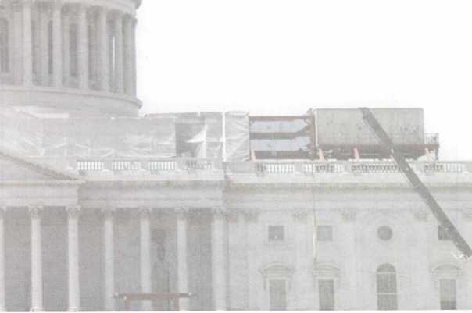

Keynotes • January 2007

**3**

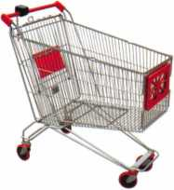

keynotes

Buyer

>r»

a

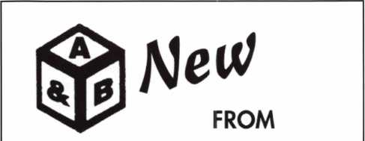

SAFE CORPORATION

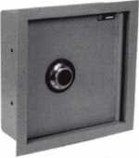

WS-6

Wall safes in two sizes 4" x6"xl 2" Deep

800-253-1267

114 S. Delsea Drive, Suite 3 856-863-1186

Glassboro, NJ 08066 Fax 856-863-1208

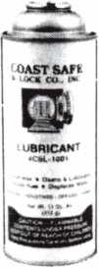

Using a general purpose lubricant? Be professional! Use a specially formulated lubricant for the Locksmith and Safe Technician trade. You and your customers will be well pleased. Guaranteed!

$48°° + shipping per case.

12-11 oz. cans per case minimum order.  
Order via phone or fax. Credit cards accepted.  
Net 30 W.A.C. or send check with order.

Coast Safe & Lock Co., Inc.

P.O. Box 66257 • Mobile, AL 36606  
(251) 479-5264 • Fax (251) 471-6967



Keynotes • January 2007

Facts on Sargent punches.

These new hand operated punches have a few unique features, plus specifications that are worthy enough to mention.

Two models are available, BP201-SGT-L and BP201- SGT-R.

Depending on milling (profile), the blanks are inserted one side or the other. Example; The L series is insert­ed from the left side and cuts bow to tip. The R series is inserted from the right side and cuts tip to bow, sim­ilar to IC products.

If your need is greater for R series, then the BP201- SGT-R will generate them from bow to tip, and the L series tip to bow. Models L or R, each does both.

The choice is yours.

SPACES:

.215" to first cut center .156" between cut centers up to seven spaces. Factory space tolerance is ± .001".

DEPTHS:

Are in increments of .020", from .330" to .150" for a total of 10 depths 1-0(10). Factory tol­erance is ± .002".

ANGLE:

Sharpest of most commercial specifications is 78 to 79 degrees. Tolerance if any is not specified by Sargent.

FLAT:

Small .051". No tolerance specified.

All of the above are incorporated in each hand punch by;

Locksmithing, Uni. LLC  
Phone: 302-575-0993  
E-mail: [ted@sargentpunch.com](mailto:ted@sargentpunch.com)



■ .rm-i.rhn

SCHLAGE

**CAL-ROYAL**

DOR-O-MATIC

jKUffliiioramac

CHICAGO

**MONARCH**

LCN

Cbrn/X

NATIONAL

**VisalocK**

• QfiESf  
Z ^VOIYMPUS^

ComiSC

FORT

**ASSA** CSmX

TIMBERLINE

**SARGENT**

DON-JO

VON DUPRIN

*TOOIS*

**« *Diumm***

AA£FX;

tfASP r-Cflflf

**AVENGER**

IBOXERW

^ ^ "———

**HIGH Jet**

LOCKCRAFT^

**BIANCHI**

I LABI MAJOR

**PRO-LOK**

*fpeterson^i/tCLH*

l *locksmith Torts MM*

*HATA*&fHX *M/k i/cnSDB*

***visa***

**VON DUPRIN** =ffcn

LO

**CKS**

<SM

■Hess

COBRA

MH **ROFU**

lull

*PADLOCKS*

**Master Lock**

_ th

'*Anniversary*

Since 1912

We are celebrating 95 years  
of saving you money l

***H.L. Flake Co.***

800-231-4105

SPECIAL NEXT DAY AIR PRICES!

Place your order by 5 PM CST  
& get your order before noon the next day!

O

0

Since 1912

**800-231-4105**

**Shop around and you will see that our  
push button lock prices are the best!**

IMERIG1N LOCK

**LIST $655**

**$299.50**

**DL2700 26D**

**ftJ th**

*Anniversary*

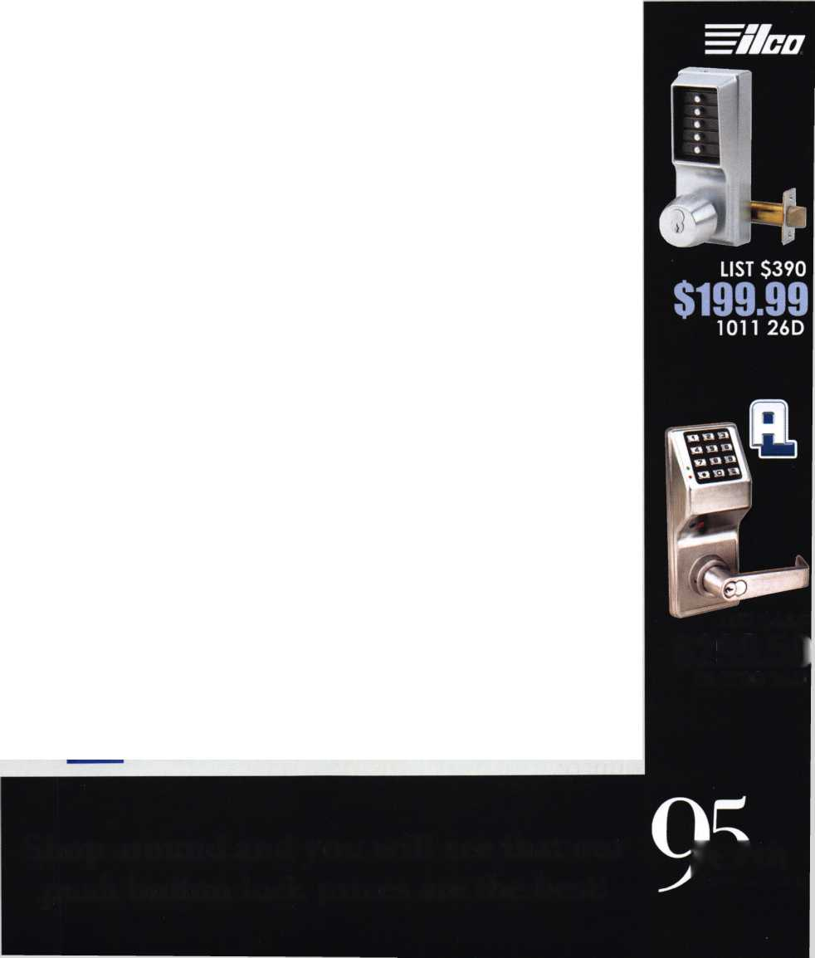

Door Hardware at Massive Athletics Complex Needs to Stand Up to Years of Use and Abuse

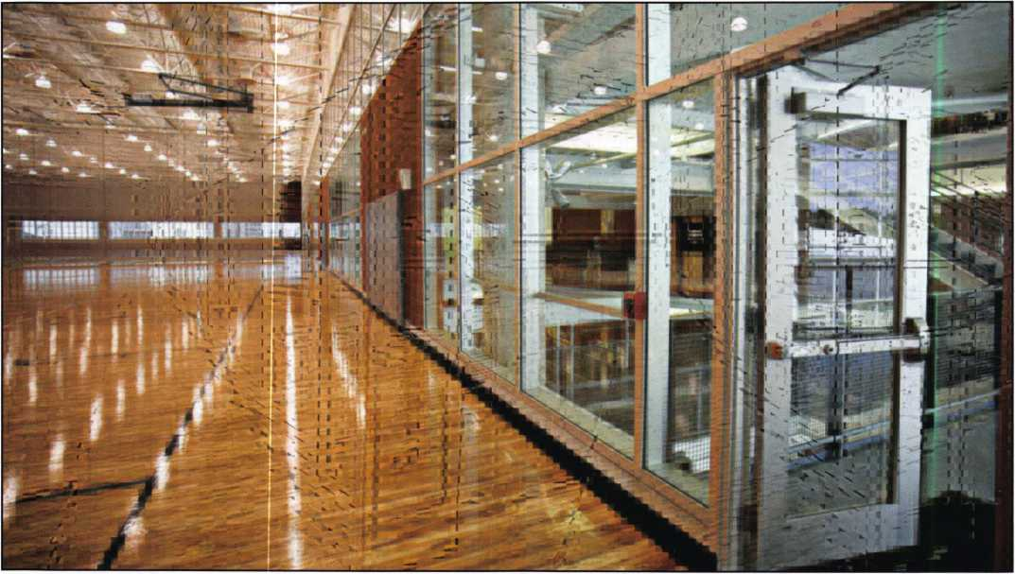

COLUMBUS - When facility man- agers at The Ohio State University (OSU), one of the nation's largest campuses, set out to build a new state-of-the-art Recreation and Physical Activity Center (RPAC), they undertook one of the largest, most complex college facility proj­ects in the country.

"We're trying to create a new image of what a recre­ation center on a college campus can be," said Diane Jensen, associate director of recreational sports at Ohio State, in a news release announcing the project.

A facility this big has a lot of pedestrian traffic to manage. Ohio State's campus houses roughly 50,000 students. And the facility isn't exclusively for students: it's open to the public and faculty as well. This results in over 5,500 people using the facility everyday or nearly 300 per hour. When Ott, Inc. helped the proj­ect team develop a hardware schedule for the complex, it looked for components that balanced outstanding durability, accessibility and high aesthetic value. The university selected a variety of products from DORMA Architectural Hardware to meet the rigor­ous demands of the RPAC.

**42**

Keynotes • January 2007

n

i

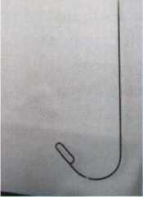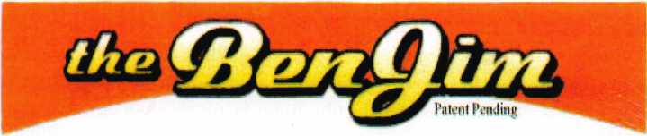

Emergency Door Opening Tools

AS SEEN AT THE 2006 A.L.O.A CONVENTION

All commercial buildings have two things in common:

* Fire code requires that all commercial locks open by a single action.
* The American Disability Act requires free access through doorways,  
  which leaves a gap between the door and the floor.

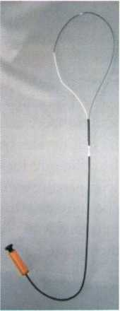

Knoblock Tool

Leverlock Tool

WITH THIS IN MIND WE HAVE DEVELOPED THE TOOLS REQUIRED TO EFFECTIVELY  
OPEN DOORS QUICKLY AND WITHOUT DAMAGE

Designed for interior commercial doors

For knoblocks, the tool is slid under the door with no cords to pull or get tangled.

For leverlocks, a similar tool is used by applying the same method of sliding the tool under the door and pull until the lever retracts.

Both tools are designed to work with very little effort, excessive force is not needed.

Visit our web site at [WWW.THEBEN-JIM.COM](http://WWW.THEBEN-JIM.COM) for more details.

THE BEN-JIM KNOBLOCK TOOL $ 99.00

THE BEN-JIM LEVERLOCK TOOL $ 79.00

SET (one each) $169.00

PLUS SHIPPING & HANDLING

**TO PLACE AN ORDER CALL 1-586-778-1911 OR VISIT US AT [WWW.THEBEN-JIM.COM](http://WWW.THEBEN-JIM.COM)**

MADE IN THE U.S.A BY THE BEN-JIM CORPORATION.

24711 Harper Ave. * St. Clair Shores * MI * 48080

(Fax) 586-778-0530

For example, DORMA's 9000 Series Exit Devices were a perfect fit for the building. Designed for high impact applications, the heavy-duty cast chassis pro­vides superior durability, while the smooth, reduced projection touchbar assembly minimizes catch hazards to address safety concerns. Over 225 DORMA 9000 Series exit devices were used on exterior doors and high-traffic interior doors throughout the four-build­ing complex. A standard finish was selected because it can hold up over long periods of time. DORMA is one of the few manufacturers that offer a true archi­tectural grade finish standard rather than plating over inferior materials.

Considering the various environments and air flow patterns within the buildings, specifiers sought a durable door closer that offered spring power adjust­ment, which would allow opening and closing power to be customized at each entryway. For instance, doors separating the warm, moist air of the pool envi­ronments from cooler, drier areas require higher spring power levels to account for added air flow. DORMA's 8900 Series Surface Door Closers were an ideal solution. Featuring a full range spring power adjustment and backcheck, along with a narrow pro­jection, full cover and flatform style arm, the 8900 Series closers delivered the perfect combination of durability, reliability and appearance. Over 600 DORMA 8900 Series closers were used on both exte­rior and interior doors at RPAC. The 8900 Series was selected with a heavy-duty parallel arm as well as a dead stop feature to stand up to the abuse of everyday use.

To meet barrier-free requirements, DORMA's ED800 Low-energy Power Operators were a cost-effective, natural fit. These operators are easy to maintain, an important factor for doors that are used by hundreds of people every day. DORMA's ED800 operators incorporate sophisticated microprocessor technology with field-proven door closers to provide accessibility for the physically challenged. The ED800 functions as a typical door closer until activated as a low-energy power operator. Eighteen ED800 Low-energy Power Operators were installed.

When completed, the massive complex will have four separate buildings: the main recreation area, two aquatics buildings and an academic building for the School of Physical Activity and Education Services.

RPAC, part of the main recreation area, features a large glass-enclosed atrium, overhead and under­ground walkways and a student wellness center. Other features of the main recreation area include a 25,000 square foot fitness conditioning space; two, four-court gyms; a four-lane jogging track; and 10 racquetball courts. Adventure Recreation Center, also part of the main recreation area, includes a climbing wall, a fit­ness/conditioning room, outdoor adventure center and a multi-activity court for indoor turf sports. The aquatic centers feature five swimming pools. The four- phase project is slated for a 2007 completion date. I

If Jamb Armor stop Giving Away Your Profits!



s Shield

Shield reinforces the leek area of rid helps prevent the door from hen kicked. Low profile model a in colors to match your locks

i Shield

tone of the system, the Jamb 144' long sleeve that wraps a lock side of the doorjamb, extremely difficult to kick in.

> Shield comes sizes to fit [5.51 and Universal [5" to 121 ling. Jamb and hinge shields

Why Your Customers Need This

* This product will save you time and make you money
* Now, you don't need to call a carp enter to fix shattered jambs

9 Multiple sales per customer and significant up-sell opportunities

9 Do you work with any landlords?

Shields fit around the existing s and help prevent hinges from id in

Shield

Why You Should Sell Door lamb Arm

Current security products only alert homeowners that they have already been violated.

This product can repair existing damage or prevent it from happening in the first place.

A unique system that  
reinforces the key strike  
points on entry doors  
and repairs damage  
from previous kick-ins

Protection

Where It's

Needed Most

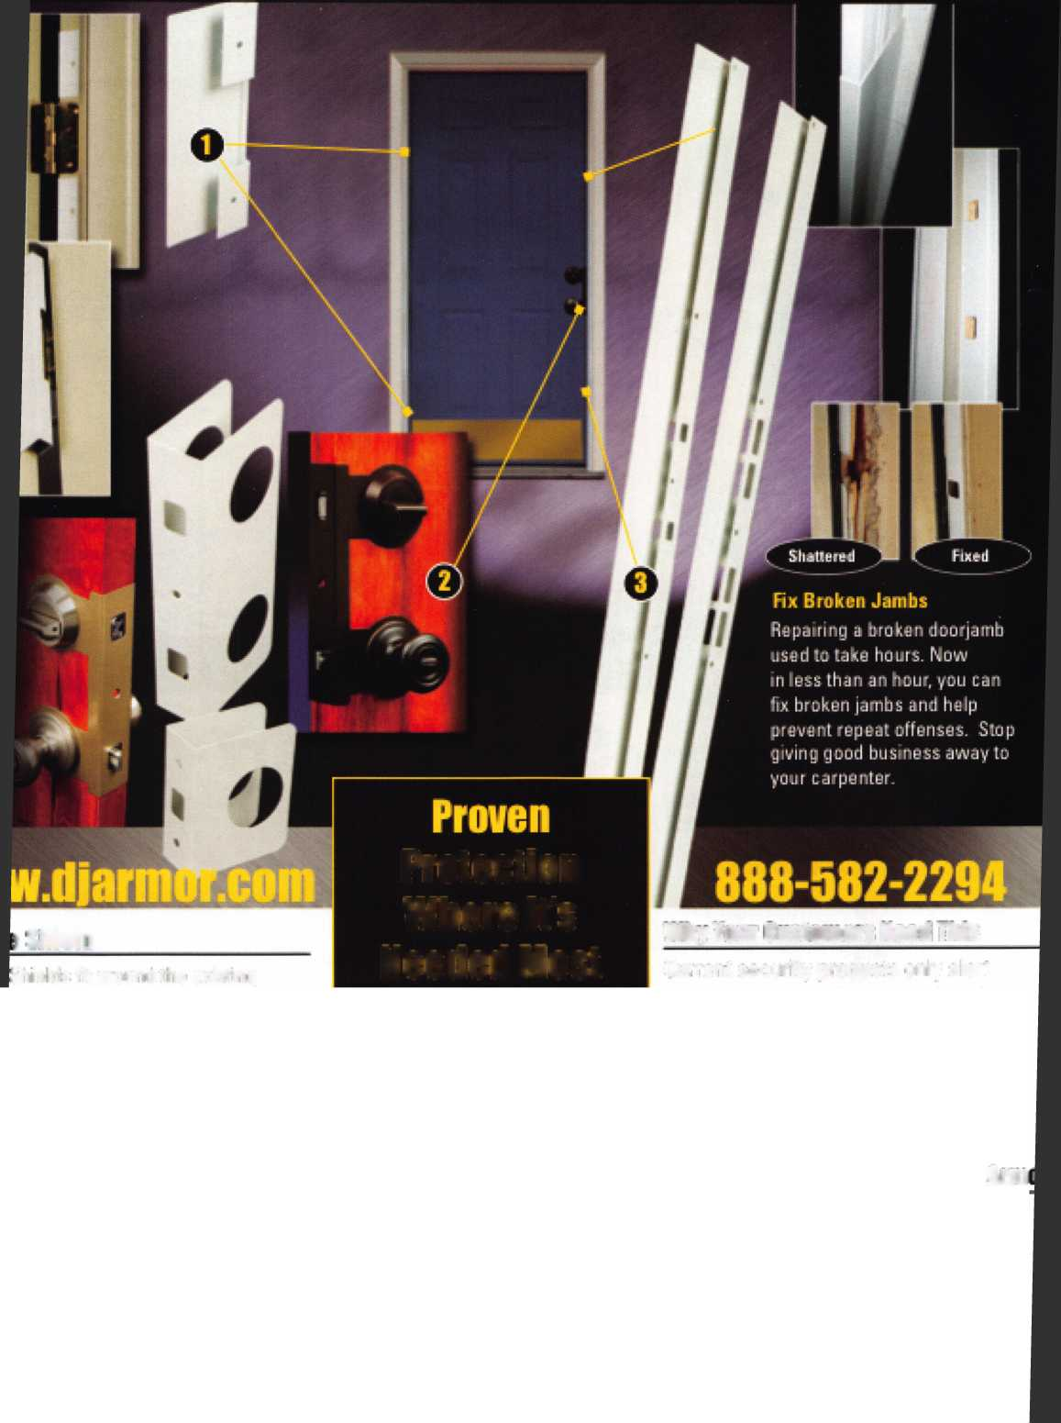

**SearchAlert**

* Available in a variety of colors and styles
* Recognized & Accepted by the TSA
* Security Window cannot be altered with a paper clip
* Security Window can only be reset by a person knowing the combination
* Zinc Die Cast Body (Not Brittle Plastic)
* Steel Shackle is virtually unbreakable

Security Window

O

**Red Window:**

Luggage has been searched.

O

**Green Window:**

Lock Not Opened.

The new SearchAlert Security window changes color from Green to Red when the TSA secured access device is used to open the lock, or when an unauthorized person has opened the lock using a counterfeit opening device. Travelers will now know when their SearchAlert Classic locks have been opened, and whether their bags have been searched by a TSA agent, or violated by an

unknown person. Protected by U.S. Patents 6,877,345 and 7,007,521. The Design of the Lock is a Registered Trademark of The Eastern Company.

***The name you can Trust for Travel safety, security*** & ***accountability.***



**Security Products** A Division of The Eastern Company A **Proud Union Company. (S.E.I.U.)**301 West Hintz Road | Wheeling, IL 60090 | Telephone: 800.733.8588 | Fax: 847.537.1881  
**wvyw.cclsecurity.com**

**TRAVEL SENTRY**

**APPROVED**

